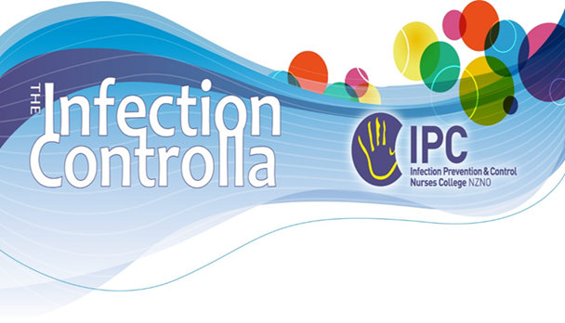The Infection Controlla:

AGM Report 2023

By Anne-Maree Wagg

Publications this year:

* March 2023
* July/August 2023
* October 2023

There have been three issues of the Controlla for 2023. Content included the usual sections: committee reports, conference info, pandemonium, and education sections and feedback. Conference feedback featured in the March edition. The Historic Corner has featured this year, I hope to see this continue.

Thank-you so much for those of you who contributed and look forward to next year’s Controlla issues.

Publications for Next year:

* Feb/March 2024
* Jun/July 2024
* November 2024 **(with a new editor as my committee term has finished.)**

Once again I am hoping 2024 will see many of our IPCNC members stories of working within their practice. 😊