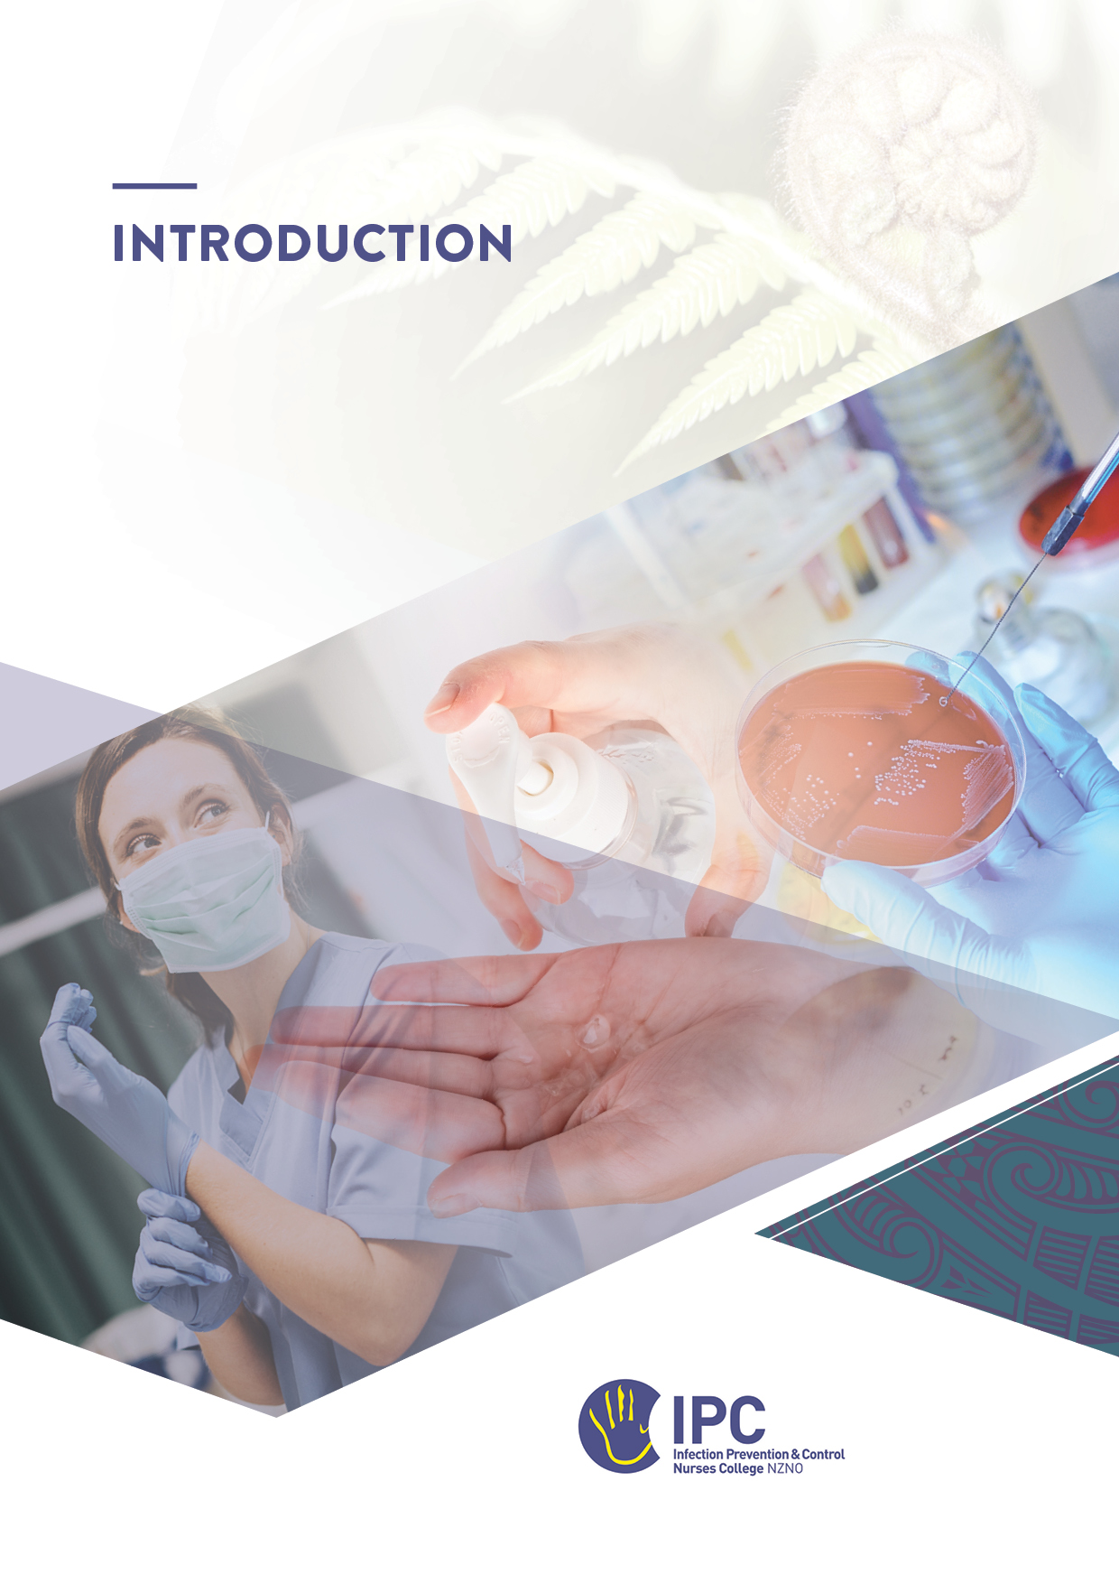

Table of Contents
Part A: Introduction to the IPCNC Fundamentals of Infection Prevention and Control Programme 2
Introduction 2
Background 2
The Programme 3
How to complete the modules 3
Timeframe for completing the programme 3
Readings and resources 4
Support for completing the modules 4
Feedback on the programme 4
Part B: Introduction to effective governance in infection prevention and control 5
IPC Standards and Governance 5
The Infection Prevention and Control Programme 5
Appendix A: Example of Governance Structure 7
Appendix B: Governance for the Beginner Practitioner 8

Part A: Introduction to the IPCNC Fundamentals of Infection Prevention and Control Programme

Introduction
Welcome to the IPCNC Fundamentals of IPC programme for new and existing infection prevention and control practitioners within New Zealand.
This programme introduces you to the key concepts that underpin the practice of infection prevention and control (IPC) in healthcare settings. Completing the modules in the programme will provide you with a consistent approach to gaining the basic body of knowledge needed when you are starting out in this important specialty.
The programme is a standardised approach to orienting to an IPC role, or providing a foundation in IPC principles, whether it is based in an acute care hospital, private ambulatory care facility, primary care, or in aged residential care. It aligns with the Professional Development Framework for the Infection Prevention and Control Nurses College in supporting new practitioners to gain the fundamental concepts needed to contribute to the prevention of HAIs and to do this in a constantly evolving environment.

Background
In the past, health professionals starting out in IPC in New Zealand have often had limited access to a structured orientation that focused on the key concepts of IPC. In 2019, to address this gap, the NZNO Infection Prevention & Control Nurses College (IPCNC) approached the Provincial Infection Control Network of British Columbia (PICNet) for permission to adapt the IPC orientation modules they had developed in collaboration with IPC professionals across Canada. PICNet generously allowed their document to be adapted for use in New Zealand as an educational tool for those joining the IPC workforce under a Creative Commons AttributionNonCommercial-ShareAlike license. Since then, the content has been revised several times to align with evolving evidence and current IPC practice in New Zealand.

The Programme
The programme consists of nine modules (10 workbooks) of self-directed learning, supported by an experienced IPC mentor. The programme is not intended to replace an accredited education course - ongoing education in IPC is essential to becoming a knowledgeable, skilled, and effective practitioner.

How to complete the modules
The modules in the programme are intended to provide you with a theoretical foundation for practice through the required readings and recommended guidance and resources, as well as giving you the opportunity to apply the key concepts in your facility or organisation.
Your mentor will work through the modules in a systematic way, beginning with the Hand Hygiene and Standard and Transmission-Based Precautions modules as they will provide you with the core knowledge for your role in IPC, whichever setting you are working in.
Each module is a stand-alone introduction to the topic and includes required and recommended online readings and other resources. Complete the required reading before you start the exercises included in each module. The modules require you to reflect on your learning and undertake written tasks with reference to the readings.
Working through the modules in this way will provide you with the information and resources needed to function as a novice before you start an accredited IPC education course. Completed modules to be submitted to your mentor for assessment and feedback.
A certificate of completion will be awarded after you have completed all the modules and submitted the evaluation form.

Timeframe for completing the programme
The modules that make up the programme are designed to be completed over four months. Progress will depend on your weekly workload as well as the time required to react and respond to any IPC issues that arise in your organisation or at a national level. For example, problems identified by environmental or practice audits, addressing concerns raised by the results of surveillance, managing outbreaks of known pathogens (such as norovirus or multi-resistant microorganisms), or contending with new and emerging diseases including Covid-19.
The IPCNC is aware of the demands made on IPC in different parts of the health sector. Some people may have sufficient time available and /or choose to complete the programme more quickly, but others work part-time and are the only person in their organisation with an IPC role. You can discuss your practice situation with your mentor, who will develop a regular meeting schedule that is suitable for different settings across the sector.

Readings and resources
All reading and resources referenced in the modules can be accessed online. A key resource is The Australian Guidelines for the Prevention and Control of Infection in Healthcare (2025) which also includes an extensive glossary of IPC terminology and definitions.
The recommended readings are also useful references for your ongoing practice. Becoming familiar with online IPC tools and resources that are evidence-based and informed by international recommendations is an important part of building your knowledge base and providing advice on specific aspects of IPC.
To gain maximum benefit from this programme, where possible, visit services and departments closely associated with IPC. These visits should be arranged with the department managers and should preferably be with an experienced member of staff who can provide the answers to any questions you may have. In some circumstances the visits may be facilitated through your manager or mentor. Examples of departments and services that would be beneficial to visit are: Microbiology Laboratory, Sterile Services, Endoscopy reprocessing, Environmental Services (cleaning), and Laundry.

Support for completing the modules
Support for completing the modules is provided through regular online mentoring sessions with an IPC mentor. If possible, the sessions will include others who are completing the programme, so that local and regional networking is part of shared learning. There are on average four virtual meetings during the four months with the opportunity for one-on-one meetings with your mentor.
Keep in regular contact with your mentor as you work through the modules. You can discuss challenges as they come up, share your observations of practice, and hear from others who are starting out in similar roles. You can also discuss any additional resources or reading that might be useful for your particular setting.

Feedback on the programme
The IPCNC asks you to provide feedback on your experience working through the modules, and how well they helped prepare you for your role in IPC. Please use the form provided by the course coordinator or your mentor or email the current College secretary directly at secretary@ipcnc.co.nz.

Part B: Introduction to effective governance in infection prevention and control

IPC Standards and Governance
The Ngā Paerewa Health and Disability Services Standard NZS 8134:2021, Section 5, is the overarching standard that guides IPC in all New Zealand healthcare organisations. Under the Health and Disability Services (Safety) Act 2001, some types of health providers are required to comply with Ngā Paerewa. Certification of these health services is administered by the Ministry of Health HealthCERT department. The HealthCERT webpages list those services required to have certification.

Governance is essential for an effective IPC programme, ensuring the safety of patients, staff and visitors in healthcare. Clinical governance within an organisation must include risk assessment/risk mitigations to support decisions/programmes of work for the prevention of of healthcare-associated infections. Governance is the responsibility of people at all levels of healthcare. Typically, in most healthcare organisations, the governing body for IPC will be the Board of Directors or a senior clinical management committee. It is important to engage a high level governing body to ensure that IPC is recognised as important for the organisation and can be incorporated into the culture of the workforce. The governing body is required to approve the IPC programme annually.
Other governance roles, such as an IPC committee, will be determined by the size and services provided by the healthcare organisation. Ngā Paerewa Section 5.1 outlines the required governance criteria for an infection prevention and control and antimicrobial stewardship programme in New Zealand. An example of a governance structure is provided in Appendix A.

The Infection Prevention and Control Programme
An IPC programme is a formal set of structures, processes and requirements that aim to prevent HAI and infectious disease outbreaks. The IPC programme describes the requirements for infection prevention and antimicrobial stewardship set out in Standard 5 of Ngā Paerewa. The IPC programme may also be an overarching document that summarises these requirements. Section 5.2 of Ngā Paerewa describes the required components of an IPC programme in New Zealand. See also Figure 1 next page.

When developing an IPC programme in your facility, several actions may be required to meet the standard. It may not be possible to implement all these actions at once, therefore it is advisable to make a risk assessment for which actions to implement, basing this on your patient/resident population, resources and infection risks. An annual IPC plan or IPC strategy will include these specific strategic objectives e.g. Objective 1: hand hygiene education; Objective 2: Updating IPC policies and procedures; Objective 3: Environmental audits.

Figure 1: Essential elements of an IPC programme (courtesy of Healthcare Associated Infections in Australia, Elsevier, 2023)

There is no national IPC programme that oversees every type of health service in New Zealand. Health New Zealand | Te Whatu Ora run several IPC programmes, primarily for the public hospitals. However, their webpages have many resources and guidelines for most healthcare organisations.

Appendix A: Example of Governance Structure

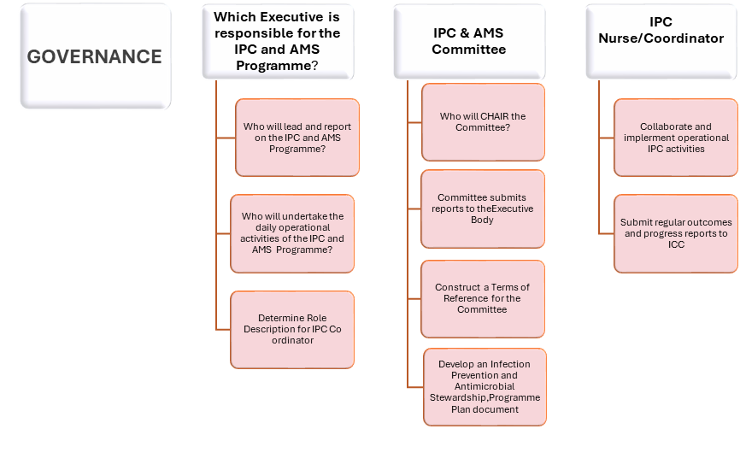

Appendix B: Governance for the Beginner Practitioner

GOVERNANCE FOR THE BEGINNER PRACTITIONER
(This information should be read alongside the diagrammatic provided in Appendix A).
As a beginner practitioner in infection prevention and control, it is both an exciting and daunting time!
The first year for novice IPC Coordinators can be very hard with little preparation for the wide scope of the work, the breadth of stakeholders ……. Nursing one minute, Facilities the next, and then Executive Leadership, all in one day!. (Martonicz,2025)
Which Executive is responsible for the IPC and AMZ Programme in your facility?
Commonly in New Zealand, Executive Leaders include corporate board management roles which are reported to by the next tier down in the hierarchy. Organisation strategy and vision sit at this level. Accountability for reducing risks of healthcare associated infections should be their first priority.
Who will lead and report to the Executive about the progress of the IPC and AMS Programme?
Usually these roles are held by Quality and Risk Managers or Clinical Services Managers/Head of Nursing. These roles are concerned with monitoring outputs, outcomes and efficiencies which maintain patient safety and best outcomes in patient care.
Who will undertake the daily operational activities of the IPC and AMS Programme?
The IPC Coordinator has this role and may recruit the assistance of others depending on the task at hand. This role reports directly to the line manager OR if there is a IPC Lead or Team Leader, the IPC Coordinator may be a direct report to the Lead. The IPC Lead would report to the Quality and Risk Manager or the Clinical Services Manager/Head of Nursing.
Determine the Role (job) Description for the IPC Coordinator
Ensure that there is a document for this role and that it is endorsed by the organisation’s People and Culture Service
The IPC and AMS Committee is integral to the democratic functioning of the IPC and MAS Programme. In small organisations the function of this Committee may be included into the organisation’s Quality and Risk Committee. The Chairperson role of this type of Committee is a senior leadership role that has a good understanding of what is required for the IPC and AMS Programme.
IPC and AMS Committee submits reports to the governing body. This pathway of reporting can be problematic with the danger of reports being submitted for the sake of reports without informed discussions at governing body level. Increasingly, digital reporting is becoming the norm with reliance on dashboard data sharing. In small organisations and/or new start ups, there may not be the digital capability therefore manual data management for reporting purposes remains important
Terms of Reference for the IPC and AMS Committee, whether it is a stand-alone Committee or morphed into a bigger Committee such as Quality and Risk, these are still necessary to navigate the stakeholders input into IPC work plans and audit results
Development of an IPC and AMS Programme document is a collaborative effort between key stakeholders in the organisation. The content for this document should mirror the compliance requirements of the Nga paerewa IPC and AMS Standard NZS 8134.5 (2021)
Effective governance allows for allocating dedicated time for the IP to undertake their IPC tasks. Asking for this dedicated time from senior leadership, rather than fitting it in on shift, ensures that the IP can commence and complete activities included in the organisation’s IPC and AMS Programme. It allows for the IP to work plan and forecast workload.
Lastly, the IPC Coordinator role very much learns on their feet and it is important to have access to subject matter expertise from experienced IPC practitioners. Outside of Te Whātu ora IPC teams there is limited resource for IPC support and it can be beneficial to seek support from the national professional body, the IPCNC network.

References
Martonicz, T W. (2025) Strengthening the Future of IPC. Infection Control Today. Oct 30.
Morgan,F (2025) Personal communication.

Example of an IPC Strategy document. Wirral University Teaching Hospital Infection Prevention and Control Strategy. https://www.wuth.nhs.uk/media/22369/wuth-ipc-strategy.pdf

