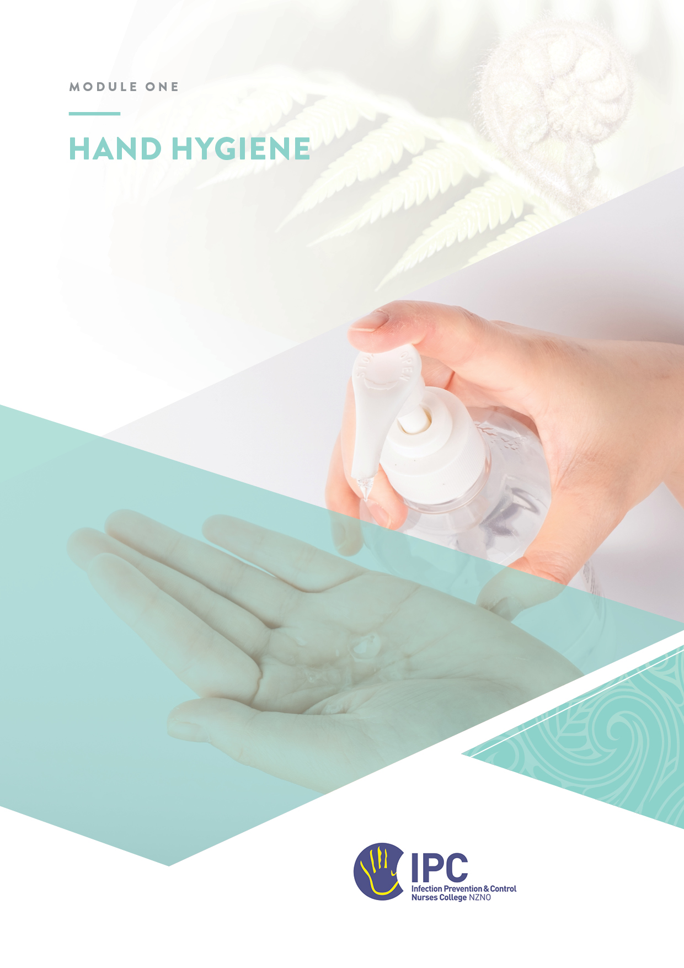

Hand Hygiene
Table of Contents
Objectives 2
Required readings 2
Recommended resources and reading 2
Instructions 2
Overview 3
Key Concepts 3
Background and evidence for hand hygiene 3
Hand hygiene methods 4
The 5 Moments for Hand Hygiene 5
Hand hygiene technique 6
Hand hygiene and gloves 6
Bare Below the Elbows 7
Hand hygiene agents and equipment 7
Hand hygiene compliance 8
Promoting hand hygiene 8
An effective hand hygiene programme 8
Putting knowledge into practice 10
The hand hygiene programme in your facility 10
Hand hygiene policy and procedures 11
Hand hygiene education and promotion 11
Hand hygiene agents used in your facility 13
Hand care 14
Hand hygiene monitoring 15
Consumer engagement 16

Objectives
At the completion of this module, you will:
- Describe the physiology of the skin and hands
- Understand the importance of hand hygiene in preventing healthcare associated infections (HAIs)
- Describe the key components of a multimodal hand hygiene programme
- Identify the indications, methods, and techniques for performing hand hygiene
- Have an understanding of the World Health Organisation’s ‘5 Moments for Hand Hygiene’ and how it applies to your workplace

Required readings
- Australian_guidelines_for_the_prevention_and_control_of_infection_in_healthcare_2024
- 3.1.1 Hand Hygiene
- Hand Hygiene New Zealand, Te Whātu ora |Health New Zealand
- Hand Hygiene Implementation Guideline
- Hand Hygiene Australia (HHA) Online Training
  - Portal for completing required hand hygiene training

Recommended resources and reading
- Hand Hygiene New Zealand, Te Whātu ora |Health New Zealand - Resources and guidance to support effective hand hygiene in healthcare settings
- Hand Hygiene Australia
- WHO Guidelines on Hand Hygiene in Health Care
- WHO Hand Hygiene in Outpatient Care, Home-based Care and Long-term Care Facilities
- Video showing how The 5 Moments for Hand Hygiene can be applied in a GP consulting room
- WHO Tips for Patients: Hand Hygiene Promotion in Healthcare
- Your facility/organisational hand hygiene policy, reports, and educational resources

Instructions
- Complete the appropriate HHNZ online learning module if not already completed. Hand Hygiene Australia (HHA) Online Training
- Read the material. Complete the answers to the questions and send the workbook to your mentor.
- Discuss any questions as required with your mentor.

Overview
Hand hygiene is the single most effective strategy in preventing the spread of healthcare-associated infections (HAIs). It is important that you have a comprehensive knowledge of hand hygiene concepts and the implementation of an effective hand hygiene programme.

Key Concepts

Background and evidence for hand hygiene
[WHO Guidelines on Hand Hygiene in Health Care – Chapters 4-7]

Who is considered to be the father of hand hygiene and why?

Name the three layers of normal skin
1.
2.
3.
Which skin layer protects us from percutaneous absorption of microorganisms?
What is the important difference between resident and transient flora of the hands in the context of hand hygiene?
Give two examples of common bacteria from each category
Resident flora | Transient flora
1.  2. | 1.  2.

Describe how healthcare-associated pathogens can be transmitted from one patient/resident to another via a healthcare worker’s hands

List two studies or publications which demonstrates a relationship between hand hygiene and healthcare associated infections
[Refer HHNZ Resource Kit for Medical Professionals - page 15 or Australian IPC Guidelines]
1.

2.

Hand hygiene methods
Define the term ‘hand hygiene’

What are two common methods/practices for performing hand hygiene
1.
2.

What is the preferred method for hand hygiene in healthcare settings and why?

Complete the following table to compare the strengths and limitations of the two methods
 | Alcohol-based hand rub (ABHR) | Soap and water
Strengths
Limitations

When should soap and water be used instead of ABHR?

The 5 Moments for Hand Hygiene
With reference to ‘The 5 Moments’, list the before and after moments when hand hygiene must be performed
1.

2.

3.

4.

5.

List other recommended times hand hygiene should be performed

List 3 specific clinical settings where the ‘5 Moments for Hand Hygiene’ can be applied and practice guidelines are available
[HH Australia Implementation or WHO Hand Hygiene in Outpatient Care, Home-based Care and Long-term Care Facilities

Hand hygiene technique
List keys points in relation to the following aspects of hand hygiene technique
Duration of procedure
Coverage of hands and areas often missed
Nail polish
Artificial nails
Rings/jewellery/ bracelets
Drying

Hand hygiene and gloves
Why doesn’t the use of gloves replace the need for hand hygiene?

When is hand hygiene performed when using gloves?

Bare Below the Elbows
Bare Below the Elbows is an initiative that aims to improve the effectiveness of hand hygiene performed by health care staff working within clinical areas.
List four things clinical staff should do, to comply with ‘Bare Below the Elbows’
[Queensland Health – Hand Hygiene – Bare Below the Elbows]
1.
2.
3.
4.

The ‘Bare Below the Elbows’ policy may conflict with some cultural and religious dress codes, particularly Muslim women who wear long sleeves. The British Islamic Medical Association suggests that alternatives to bare below the elbows are 3/4 length sleeves or disposable oversleeves. Full-length sleeves are permissible if not involved in direct patient care (https://britishima.org/advice/hijab-bare-elbow-infographics/).

Hand hygiene agents and equipment
[Australian IPC Guidelines / HHA Alcohol-based handrubs]
No matter which method of hand hygiene performed it is important to select the right products / agents and equipment.
List the keys points of consideration with each of the following:
Concentration of alcohol in ABHR used in healthcare settings
Plain vs. antimicrobial soap for hand washing
Ease of access to hand hygiene facilities
Hand drying methods
Placement of ABHR

Hand hygiene compliance
List four factors that reduce hand hygiene compliance
[WHO HH Guidelines - Chapter 16]
1.
2.
3.
4.

Promoting hand hygiene
World Hand Hygiene Day is celebrated on 05 May each year, a global campaign led by the World Health Organisation. Each year the SAVE LIVES: Clean Your Hands campaign website provides resources and promotional material freely available to use.

An effective hand hygiene programme
Hand Hygiene NZ has adopted the WHO multi-modal approach to establishing best hand hygiene practice for every patient, every time.
The key elements of this approach are:
- system change, including availability of ABHR at the point of patient care.
- training and education of health care professionals.
- monitoring of hand hygiene practices and performance feedback.
- consumer/patient engagement.
- commitment to hand hygiene and a patient safety culture by individual health care workers and senior leadership.

Figure 1: A multi-modal approach to improving hand hygiene (HHNZ)

Leadership
Senior management support
Policies & Procedures

Effective Hand Hygiene Programme
Infrastructure
User input into product selection and placement
Point-of-care ABHR
Free-standing hand washing sinks

Ongoing Monitoring
Compliance, performance indicators and feedback to healthcare providers

Education
Staff motivation, education, and training
Visual workplace reminders

Champions and Role Models
Opinion leaders and champions modeling the right behaviour

Consumer/
Patient Engagement
Consumer/patientfamily, whānau engagement through education

Putting knowledge into practice

The hand hygiene programme in your facility
The Ngā Paerewa Health and Disability Services Standard NZS 8134:2021 requires all facilities to provide a safe environment for health care staff, clients/patients, and visitors. While health care settings differ, ready access to ABHR at point of care, hand hygiene training and education, monitoring and reporting of adherence to best practice, consumer/patient engagement, and leadership and support from managers, are integral to building a strong commitment to hand hygiene and a patient safety culture.

Review the hand hygiene programme in your facility
Are the following components of a hand hygiene (HH) programme implemented?
Component | Implemented / Applied (Yes / No)
Leadership support
- Managerial commitment to promoting HH and patient safety
- Written policies and procedures
Infrastructure and facility
- Point of care ABHR
- Adequate number of handwash basins
- User input into HH products
Education & training
- Formal staff education
- Online resources
- Posters/reminders
Champions and role models
- Management
- Clinical
Ongoing monitoring & feedback
- Audits
- Compliance reports
Consumer/patient engagement
- Strategies to engage patients
- Posters
- HH products for patients

Hand hygiene policy and procedures
Review your facility’s policy and procedures for hand hygiene
How often is the documentation required to be revised/ updated?
Where can staff access the hand hygiene policy?
Highlight or underline all elements that are included in your facility’s hand hygiene policy
- Indications for hand hygiene
- Indications for the use of soap and water or ABHR
- Description of ‘The 5 Moments for Hand Hygiene’
- Instructions for HH techniques
- Placement of ABHR containers
- Responsibilities for replacing ABHR and soap containers
- Use of artificial nails, jewellery & nail polish
- Hand care
- Hand hygiene compliance monitoring/audits
- Engaging patients / residents / clients / visitors
Do you have any suggestions on how your hand hygiene policy might be improved?

Hand hygiene education and promotion
Review your facility’s present HH education programme | Yes / No
Does the facility have an HH education program?
Are staff required to complete ‘The 5 Moments for Hand Hygiene’ training?

Outline staff education, including if mandatory, when, how often
Staff group | Mandatory? | Orientation / induction | Refresher timeframe
Clinical staff
Support (laundry, kitchen, maintenance etc.)
Clerical (reception, office)
Who has responsibility for the delivery of the HH education?
Are the following topics covered? Yes / No
- Importance of and indications for HH
- Techniques for HH
- Strategies to maintain healthy hands
- Appropriate use of gloves
- Use of artificial nails, nail polish & jewellery
Which staff groups are required to complete the HHA ‘5 Moments’ online assessment?
List any teaching aids available in your institution for hand hygiene education (e.g. fluorescent lotion (‘Glitterbug’ / ‘Glo-Germ’)

Review the posters and other visual cues available to promote hand hygiene in your facility.
Where have the posters been sourced from (e.g. in-house, Te Whātu ora etc.)?
How long since they were last changed?
Is there a process to change them at certain intervals?

Hand hygiene campaigns to improve hand hygiene
Regular (e.g. annual) or one-off campaigns (e.g. in response to poor practice in specific units or areas highlighted by auditing) can be used to improve hand hygiene in healthcare facilities.

Does your facility use any of these promotional campaigns? | Yes/No
World Hand Hygiene Day - May 5
Infection Prevention and Control Week
A wider patient safety campaign
Describe the components or activities of one these campaigns used to promote HH in your facility (if applicable)?

Hand hygiene agents used in your facility
Review the hand hygiene agents in use in your facility
List the departments / services involved in choosing hand hygiene products?
1.
2.
3.
Which of the following types of hand hygiene agents are provided in your facility?
- Plain liquid soap Yes / No
- Antimicrobial soap Yes / No
- ABHR Gel /rub / foam / wipes
- Surgical ABHR hand antisepsis product Yes / No
- Hand lotion Yes / No
What were the key considerations for choosing the ABHR product used in your facility?
Can you identify any instances of poor ABHR placement? Describe the problem and how this could be improved.

Hand care
Review the hand care procedures in your facility
Does a strategy exist for hand care to promote healthy skin?
Which department is involved in the hand care strategy?
What is the process when a healthcare worker presents with breaks in skin integrity?
Are there alternative HH products available for staff with genuine skin sensitivities to agents used in the facility?
List actions to promote hand care

Hand hygiene monitoring
Review the hand hygiene monitoring or auditing process in your facility
Which of the following processes are used to monitor HH compliance Yes / No
- Monitoring amounts of usage of HH products
- Regular audits for compliance with ‘The 5 Moments for Hand Hygiene’
- Audits of HH techniques
- Automatic HH sensors on entering patient room
- Product availability audits
- Patient / client feedback survey

Answer the following questions if your facility uses audits to monitor HH compliance
Who conducts the audits?
Do the auditors receive training in undertaking the audits?
What is the source of the audit tool e.g. in-house, Te Whātu ora, HHA?
Are the audits part of a national or multi-facility programme?

Documentation and Reporting
The completion of post audit documentation and reporting to stakeholders are among the most important steps in a successful hand hygiene audit, including:
- completing the summary score sheet
- determining recommendations
- meeting to discuss findings and recommendations
- preparing a final report to be distributed to key stakeholders in your facility

Reporting audit results
Who analyses the data from the audits and writes the reports?
How often are HH audit reports created?
How are management provided with feedback and results from the audits?
How are staff provided with feedback and results from the audits?
Where are HH results publicly displayed?
Are any improvement actions identified from reports?
Are there timelines as to when the items will be actioned?
Who is responsible for implementing any changes recommended by the audits?

Te Whātu ora | Health New Zealand HHNZ compliance reports
Te Whātu ora | Health New Zealand collect hand hygiene compliance data as a quality and safety marker (QSM) of healthcare provided in the public sector. Results are published on the Health Quality & Safety Commission (HQSC) QSM dashboard.
Familiarise yourself with the Hand Hygiene Compliance data and reports on the HQSC QSM dashboard. Click on the latest QSM report in the left sidebar and then Hand Hygiene
What information do they provide to Te Whātu ora managers, health care workers, and the general public about hand hygiene compliance?
Are other aspects of the multimodal improvement programme included in the reports?

Consumer engagement
Consumer/patient engagement in hand hygiene promotion refers to the participation of patients/clients/residents in supporting hand hygiene best practices in healthcare settings. While the responsibility for hand hygiene rests with the healthcare worker, consumers/ patients and their families/whānau should be encouraged and enabled to engage in supporting best practice for every patient, every time e.g. by being involved in initiatives to improve hand hygiene compliance and reduce HAIs.
Online resources include the WHO Tips for Patients: Hand Hygiene Promotion in Healthcare,
HHNZ Patient Participation Guidelines, and the HQSC Engaging with consumers

Review your facility’s patient/ consumer engagement programme / resources
Hand hygiene products for patients / residents and visitors
Which HH products are available for consumers/patients?
Where are these located?
List any strategies that engage consumers/patients in promoting and engaging in hand hygiene practice

