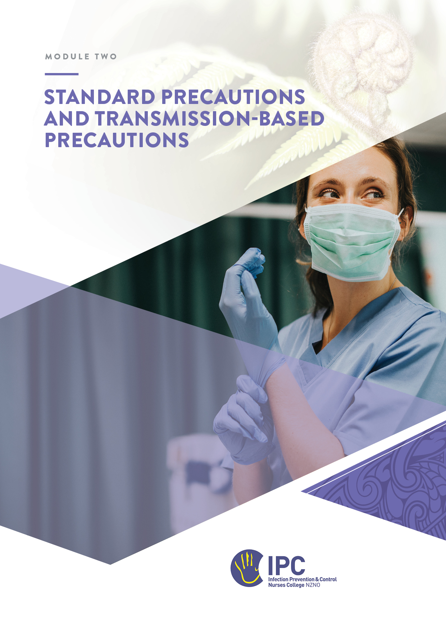
Part 1. Standard Precautions

Standard Precautions

Table of Contents
Standard and Transmission-based precautions 2
Objectives 2
Required readings 2
Recommended readings and resources 2
Instructions 3
Overview 4
Key Concepts 4
The Chain of Infection 4
One Health and sources of infectious agents 6
Standard Precautions 6
Applying a risk management approach to Standard Precautions 7
Hierarchy of Control measures 9
Elements of Standard precautions 10
Hand hygiene 10
Respiratory hygiene 10
Placement of patients and source control 10
Aseptic technique 11
Personal Protective Equipment 13
Sharps safety and prevention of transmission of blood borne pathogens 16
Handling of linen and waste 16
Routine environmental cleaning 17
Cleaning, disinfection and sterilisation of equipment 18
Appendix A: Standard Precautions poster- ACSQH 19
Appendix B: WHO Standard Precautions in Health Care 20
Appendix C: Research article relating risk assessment for Standard Precautions 22
Appendix D: Promotional posters for optimal glove use 23

Standard and Transmission-based precautions
Module 2 - Standard and Transmission-based precautions - comprises two parts. Part 1 is the learning for Standard Precautions (this workbook) and Part 2 for Transmission-based precautions.
Standard and Transmission-Based Precautions form the foundation for all infection prevention and control activities. You will utilise your knowledge of these concepts for the development of policies and procedures, teaching of staff, and for the auditing and monitoring of practices in the clinical area.
Standard precautions are the work practices required to achieve a basic level of infection prevention and control. Standard precautions are the minimum infection prevention and control practices that must be used at all times for all patients in all situations.
Transmission-based precautions are used when standard precautions alone are not sufficient to prevent the spread of an infectious agent. Transmission-based precautions are based upon the mode of transmission of the infectious agent.

Objectives
At the completion of this module you will:
- Identify the key components of Standard Precautions.
- Demonstrate an understanding of the application of Standard Precautions in your clinical area.

Required readings
- Australian Guidelines for the Prevention and Control of Infection in Healthcare:
  - 3.1 Standard Precautions
  - 3.3 Personal Protective Equipment (PPE)
  - 3.1.3 Routine management of the physical environment
  - 3.1.6 Aseptic Technique

Recommended readings and resources
- CDC: Standard Precautions for All Patient Care
- Te Whatu Ora Infection Prevention and Control – Standard Precautions
- World Health Organisation: Standard Precautions in Healthcare
- Research article: ‘Home care nurses’ identification of patients at risk of infection and their risk mitigation strategies: A qualitative interview study’. (Dowding et al. 2020). https://doi.org/10.1016/j.ijnurstu.2020.103617
- New South Wales Clinical Excellence Commission. Infection Prevention and Control Practice Handbook - Version 4.0 November 2025. Chapter 5.

Instructions
- Read the material.
- Complete the answers to the questions and email the completed workbook to your mentor.
- Discuss any questions as required with your mentor.

Overview
Standard precautions are routine work practices that are implemented consistently to achieve a basic level of infection prevention and control.
They are the minimum set of practices in healthcare and must be applied for all patients in all situations. Everyone is potentially a source of infectious pathogens and therefore all blood and body substances must be considered as potentially infectious. Using Standard Precautions will help break the ‘Chain of Infection’ from an infectious source to a vulnerable patient or staff member promoting safety for everyone.

Key Concepts

The Chain of Infection
Transmission of infection within a healthcare setting requires all of the following elements:
- causative or infectious agent
- reservoir
- portal of exit
- means of transmission
- portal of entry
- a susceptible host.
A break in any of the links in the chain of infection can prevent the transmission of infection. The diagram on the following page describes these elements and gives examples of how each link can be broken with IPC measures.

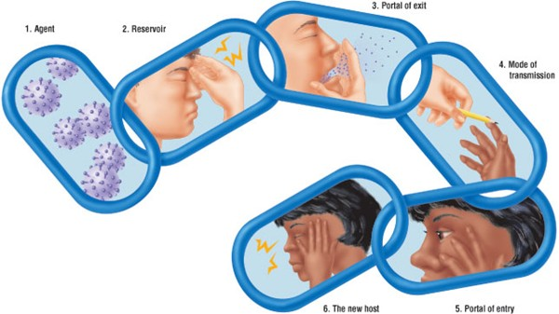
Figure 1: Chain of infection for respiratory infections

Using Influenza as the disease, complete Table 1 by providing examples of how you would break each link in the chain of infection to prevent transmission of this infectious disease. The link ‘Reservoir’ has been completed as an example.
Table 1: Breaking the Chain of Infection for Influenza.
Influenza ‘chain of infection’ link | IPC measure(s) that break the link
Agent | Influenza
Reservoir | - Staff immunity through immunisation and influenza vaccination  - Effective environmental cleaning  - Disinfection or sterilisation of reusable equipment
Portal of exit
Mode of transmission
Portal of entry
Susceptible (new) host
Figure 2: The Chain of Infection

One Health and sources of infectious agents
The reservoir for an infectious agent may not always be a human. Animals, insects and the external and internal environment are other sources of infectious agents.
The One Health concept is an approach that recognises that the health of people is closely connected to the health of animals and our shared environment. Infectious diseases are an important issue for One Health. For a more in-depth understanding of this concept see CDC One Health Basics.
In New Zealand One Health Aotearoa is an organisation committed to using an integrative approach to understand, prevent, and control infectious disease.
Consider which infections or infectious diseases can be found in non-human sources and complete Table 2 below:
Table 2: Sources of infection
Source of infection | Examples of infectious diseases
Animal
Insect
Indoor environment
Outdoor environment e.g. water, soil

Standard Precautions
Standard Precautions are the minimum infection prevention practices that apply to all individuals in all settings where healthcare is delivered. They are based on an individual’s assessment of the risk of exposure to blood and body substances which may occur during the episode of care or activity at the time.
Standard Precautions make use of basic hygiene practices and personal protective equipment (PPE) that prevent the spread of infection to patients and protect healthcare workers from infection.
Standard Precautions consist of the following practices:
- Hand Hygiene
- Personal Protective Equipment
- Safe use of sharps
- Management of blood and body fluid spills
- Aseptic technique
- Respiratory Hygiene
- Cleaning, disinfection and sterilisation of equipment
- Linen and waste management
- Environmental cleaning

Complete Table 3 by providing examples of measures or practices used in your facility for each of the Standard Precautions listed.
For examples refer to Section 3.1 in the Australian Guidelines for the Prevention and Control of Infection in Healthcare and Appendix A: Standard Precautions poster- ACSQH and Appendix B: WHO Standard Precautions in Health Care.

Table 3: The application of Standard Precautions in your facility
Standard Precaution | Examples of how this is applied to your facility
Hand hygiene
Personal protective equipment (PPE)
Safe use of sharps
Management of linen and laundry
Management of infectious waste
Cleaning, disinfection or sterilisation of shared equipment

Applying a risk management approach to Standard Precautions
The risk of a healthcare-associated infection (HAI) may be defined as the possibility of microorganisms colonising or infecting patients or healthcare workers arising from activities performed within a health care facility.
Risk management to prevent and reduce harms from HAIs occurs on many levels within a healthcare facility or organisation:
- Facility wide—through organisational risk-management policies, appropriate construction and ventilation, staff training and education, follow-up of outcomes, monitoring and reporting.
- Ward or department based—embedding risk management into all policies so that risks are identified, eliminated, isolated and/or minimised in every situation.
- Individual—for example, doing a risk assessment before carrying out a specific procedure as part of clinical decision-making to determine PPE usage.
Organisations may have a risk register which includes IPC risks.

Individual healthcare settings differ markedly so it’s not possible to provide a one size fits all approach to managing the risk of infection transmission.
However, all healthcare facilities need to be able to determine the risks in their own context and ensure that all staff understand how to apply and adhere to Standard Precautions in their daily practice.
Describe any organisational risk management strategies used in your facility to reduce the risk of infection transmission

Being able to perform a thorough risk assessment is fundamental to practicing IPC. As an IPC practitioner you need to have a good understanding of how to do a risk assessment, how to include it in every patient interaction, and how to use the findings to implement appropriate IPC practices.
You will be required to educate healthcare workers about risk assessment and reinforce its use frequently because by applying the appropriate measures they are reducing risk to themselves (and other staff members), consumers/patients and their families/whānau and visitors.
Before every patient interaction, all healthcare workers have a responsibility to assess the infectious risk posed to themselves and others by a patient/resident, situation, or procedure in a specific environment. The risk assessment will determine the appropriate actions to protect the patient from transmission of microorganisms (e.g. by appropriate hand hygiene, the use of aseptic technique, and cleaning and disinfection of patient care equipment) and to protect the healthcare worker from exposure to microorganisms (e.g. from sprays of blood, body fluids, respiratory tract or other secretions or excretions and contaminated needles and other sharps).
The abstract of the research article listed above and available HERE (see also Appendix C: Research article relating risk assessment for Standard Precautions - Abstract) provides a good description of how home care nurses make a risk assessment for infection and what strategies they use to mitigate those infection risks. Read the article abstract and answer the following questions:
What did the authors conclude was the main strategy for infection prevention?
List three factors identified by the nurses in this study as putting a patient at higher risk of infection
1.
2.
3.

Factors that influence the risk of transmission of infection
Factors that influence the transmission of infectious pathogens include the mode of transmission for the pathogen or disease, patient characteristics and the physical environment.
In the table below each scenario will have different factors for infection transmission. Make a risk assessment for each scenario and complete the table.
Table 4: Risk assessment scenarios
Infection risk scenario | Hospital inpatient develops diarrhoea and vomiting on Day 5 in a shared room | Person waiting in outpatients or clinic has symptoms of upper respiratory tract infection | There is a large blood spill on the patient lounge floor from a dislodged IV cannula
What is the likely infectious disease(s) or pathogen(s) that can be transmitted?
What are the risks for transmission?
Which IPC measures would you implement to mitigate the risk?

Hierarchy of Control measures
The hierarchy of controls concept can also be used when considering strategies to prevent and control the transmission of infection.
Figure 3: Hierarchy of Controls for infectious agents
Using the hierarchy of controls, complete Table 5 by providing specific examples of control measures to prevent transmission of COVID-19 in your workplace and who is responsible for these – organisation/management or the individual or both.
Table 5: Hierarchy of control measures
Control | Examples of practical measures used | Responsibility
Engineering
Administrative
Personal protective equipment (PPE)

Elements of Standard precautions

Hand hygiene
Hand hygiene is a key component of Standard Precautions. Refer to the Hand Hygiene Module for further information and reflective exercises.

Respiratory hygiene
People with signs and symptoms of a respiratory infection should be directed to follow respiratory hygiene and cough etiquette. This includes:
- Covering the nose/mouth when coughing or sneezing or using the crook of the elbow to contain respiratory droplets
- Using tissues to contain respiratory secretions and discarding in the nearest waste receptacle after use
- Performing hand hygiene immediately after contact with respiratory secretions and contaminated objects/ materials.
Supplies such as tissues, waste bins, and alcohol-based hand rub should be made available to facilitate respiratory hygiene in common areas and waiting rooms.

Placement of patients and source control
Infected patients are the main source of pathogens in healthcare settings and reducing or preventing the spread of the infectious agent from the source is critical. Source control measures include promotion of respiratory hygiene, early recognition and investigation, prompt implementation of IPC precautions, reporting and surveillance, and treatment to make patients non-infectious.
Other measures include the implementation of spatial separation (e.g. ensuring patients with acute respiratory illnesses are at least 1 metre from others in waiting rooms and are provided with a medical mask to protect others from their infectious respiratory secretions), the erection of partitions to protect healthcare staff from potential exposure to infectious agents, and where appropriate placing patients directly into a single room.
Complete Table 6 by providing examples of source control measures and optimal infectious patient placements for someone presenting with signs and symptoms of an upper respiratory tract infection in the following clinical settings.
Table 6: Patient placement and source control examples
Area | Source control examples | Optimal placement
Emergency department
GP surgery / outpatient clinic/ private surgical clinic
Residential aged care facility
Inpatient hospital ward

Aseptic technique
Aseptic technique is a set of practices that are used whenever a procedure is performed to protect patients from exposure to potentially infectious microorganisms.
Applying aseptic technique in practice involves:
- risk assessment and planning before the procedure
- avoidance of environmental risk factors
- appropriate hand hygiene practice
- cleaning and disinfection of equipment
- skin antisepsis as appropriate
- the use of barriers as necessary (e.g. sterile gloves)
- sterile equipment and instruments; and
- ensuring that sterile barriers or materials do not touch non-sterile surfaces.

Before starting a procedure, risk assessment and careful preparation of the environment, patient and equipment are essential to reduce the risk of contamination. This includes considering how to protect ‘key parts’ and ‘key sites’.
- ‘Key parts’ are those parts of sterile equipment that penetrate the skin or an indwelling device, or come into contact with sterile solutions. ‘Key parts’ should only be touched with uncontaminated sterile gloves, if this is a necessary part of the procedure you are undertaking.
- ‘Key sites’ are parts of the body, an indwelling device, or a solution container that are penetrated during the procedure. Key sites can only be touched with sterile cleaning agents, sterile dressings or sterile gloves during the procedure if this is absolutely necessary.
Hand hygiene is an essential component of aseptic technique. At a minimum, it must be performed before setting up your equipment, before the planned procedure, and after the procedure.
In emergency situations aseptic technique cannot always be applied. Where there has been a breach, this should be documented, included in handover, and the infection risks reduced (e.g. by removing a peripheral or central IV line inserted under emergency conditions and replacing it under aseptic conditions).

Resources
- Examples of the use of aseptic technique during peripheral and central access intravenous therapy, and wound care, are outlined in the: Australian Guidelines for the Prevention and Control of Infection in Healthcare: (p. 97-102)
- The New Zealand Aseptic Technique resources are available HERE
- A good overview of aseptic technique from the UK Nursing Times is found HERE

Aseptic Non-touch Technique (ANTT®) (www.antt.org)
ANTT refers to aseptic non-touch technique. It is trademarked to protect the intellectual property rights to ensure the technique remains explicitly defined and quality controlled.

Procedures requiring aseptic technique are frequently performed in healthcare. Complete Table 7 by identifying the key parts and key sites for aseptic technique in the procedures below.
Table 7: Key sites and Key parts
Procedure | Key parts | Key sites
Insertion of urinary catheter
Access of peripheral IV line
Insertion of central line
Dressing a leg ulcer
Administering enteral feeds

Personal Protective Equipment
Personal protective equipment (PPE) is any type of specialised clothing, barrier product, or breathing (respiratory) device used to minimise exposure to hazards and protect workers from serious injuries or illnesses while doing their jobs.
Personal protective equipment acts as a barrier between infectious materials and the skin, mouth, nose, or eyes (mucous membranes). In the application of Standard Precautions, PPE includes gloves, gowns, and face protection: masks, goggles, and face shields. Glove use is not a substitute for hand hygiene.
Personal protective equipment (PPE) in Transmission-based Precautions includes respirators in addition to the requirements listed above.

In Tables 8a to 8d, complete the answers for the different items of PPE used as part of Standard Precautions.
Table 8a: Gloves
Question | Answers
What are the indications for using non-sterile examination gloves?
Whom are non-sterile gloves protecting?
What are the key errors noted when putting on or taking off exam gloves?

Gloves are often worn when there is no infectious risk identified. This over-use of disposable gloves is a concern because they are a barrier to good hand hygiene and complying with the 5 Moments for Hand Hygiene. This video clip from the Royal College of Nursing in the UK identifies the issues with inappropriate glove use and is a good resource for teaching staff. Refer also Appendix D: Promotional posters for optimal glove use.

Why do you think health care workers use gloves so often when they are not indicated?

The World Health Organisation describes the hierarchy of glove use in Figure 4.
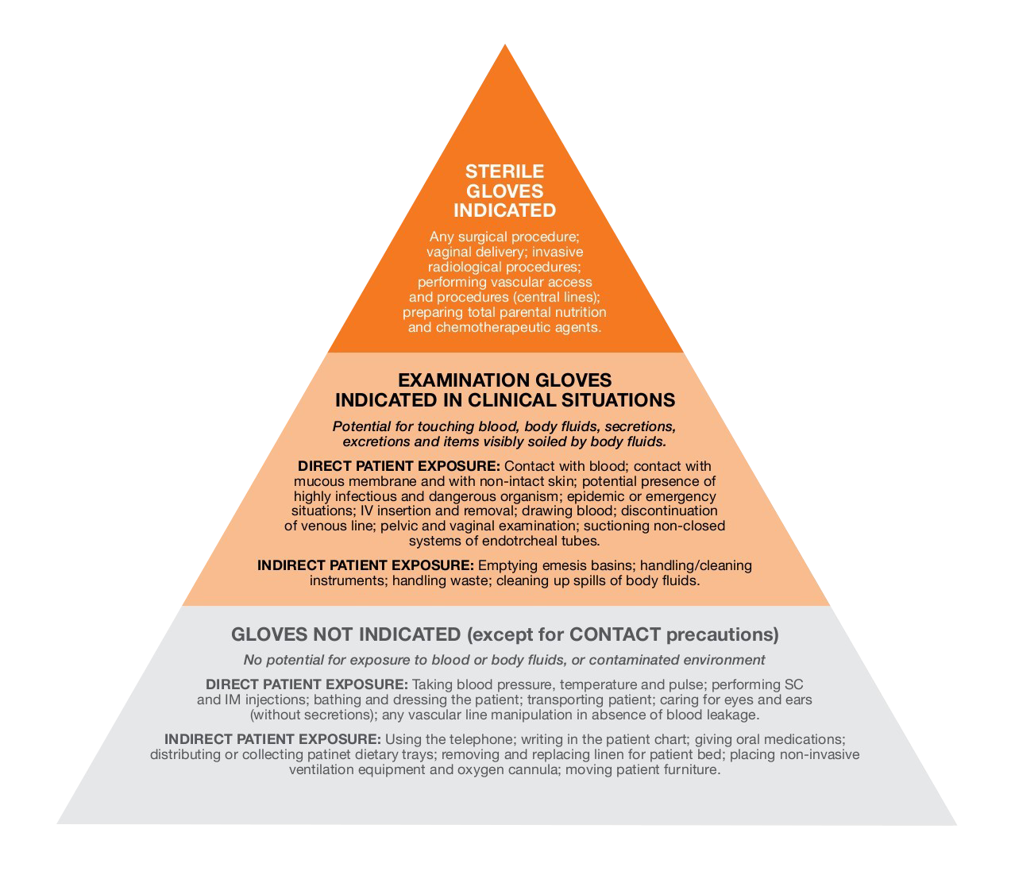
Figure 4 WHO hierarchy of gloves use

Non-sterile gowns or aprons
Resources
- NHMRC IPC Guidelines - Australian Guidelines for the Prevention and Control of Infection in Healthcare: Section 3.3 Personal Protective Equipment (PPE)
- Overview of different gowns used in healthcare: FDA – Medical Gowns
Using the sources of information above, complete Table 8b
Table 8b: Gowns and aprons
Question | Answers
What are the indications for gown use?
Whom is the gown protecting?
What are the key errors noted when putting on or taking off a gown?
What type of gown or apron is used in your facility?

Surgical masks
Respirators are not considered PPE for standard precautions and are included in Part 2 - Transmission-based Precautions

Resources
- NSW CEC IPC Handbook – Chapter 5 - 5.8 Respiratory and facial protection
Using the source of information above, complete Table 8c
Table 8c: Surgical masks
Question | Answers
How many levels of surgical mask are there?
What are the indications for using an ATSM level 3 surgical mask?
What is the manufacturing Standard for disposable surgical masks that should be used in NZ?
List 3 things that surgical masks are tested for in the above Standard | 1.  2.  3.

Eye protection – face visor or safety glasses / goggles
Complete the following table
Table 8d: Using eye protection
Question | Answers
List examples of eye protection
What are the indications for using eye protection in your facility?
What are the IPC considerations for reusable eye/face protection?

Sharps safety and prevention of transmission of blood borne pathogens
Review the policies and procedures on sharps safety and policiy for blood and body fluid exposures in your facility. Complete Table 9.
Table 9: Sharps safety
Question | Answers
Name at least two safety precautions when handling sharps.
When are sharps injuries most likely to occur?
Are there structures in place so that needles can be disposed of at the point of care in your facility?
Does your organisational policy provide direction as to when sharps containers should be removed and replaced?

Handling of linen and waste
Review your facility policies for handling linen and waste and complete the tables below’
Table 10: Linen and laundry management
Linen and laundry management
List two requirements for the storage of clean linen
How is soiled or infectious linen managed?
What is the regulatory Standard required for laundry practices

Table 11: Waste management
Waste management
What is the colour of bags used for infectious waste
List two requirements for the storage of healthcare waste prior to collection
What is the regulatory Standard required for management of healthcare waste in New Zealand

Routine environmental cleaning
Environmental cleaning is important in all healthcare settings to prevent the transmission of infectious agents from contaminated surfaces or equipment to patients, healthcare workers and other/. This can occur through direct contact, or by indirect contact, for example via healthcare workers’ hands that have been in contact with contaminated surfaces or equipment.
A detergent solution is recommended for routine cleaning. The level of cleaning required depends on the risk of contamination, for example shared clinical equipment, which is likely to be contaminated, requires cleaning between each patient use. Frequently touched surfaces, such as doorknobs and call bells, should be cleaned more often than minimally touched surfaces such as ceilings, walls and offices.
Intensive care units and isolation areas require additional levels of cleaning, especially where there is a risk of transmission from an organism of concern such as a multidrug resistant organism. Routine cleaning is increased, and the use of a detergent solution is followed by the use of a disinfectant so that surfaces are both cleaned and disinfected. Alternatively, two-in-one products which combine cleaning and disinfection may be used.
See Module 8: Cleaning, Disinfection and Sterilisation of Medical Equipment and Devices for more information on cleaning and disinfection. In addition, the South Australian Cleaning Standards provide information and cross reference charts linking the elements, functional areas and weightings of areas to be cleaned and audited within healthcare services.
Review your organisation/facility cleaning schedule and complete Table 11.
Table 11: Environmental cleaning in your facility
Question | Answers
When is increased cleaning recommended?
What products are used for routine cleaning?
What disinfectant product is used for an enhanced/ terminal/infectious/isolation clean?
What PPE is advised for cleaning blood and body fluid spillages?
Is there a process for regular review or audit of routine environmental cleaning?

Cleaning, disinfection and sterilisation of equipment
This element of Standard Precautions is covered in Module 8.

Appendix A: Standard Precautions poster- ACSQH

Appendix B: WHO Standard Precautions in Health Care
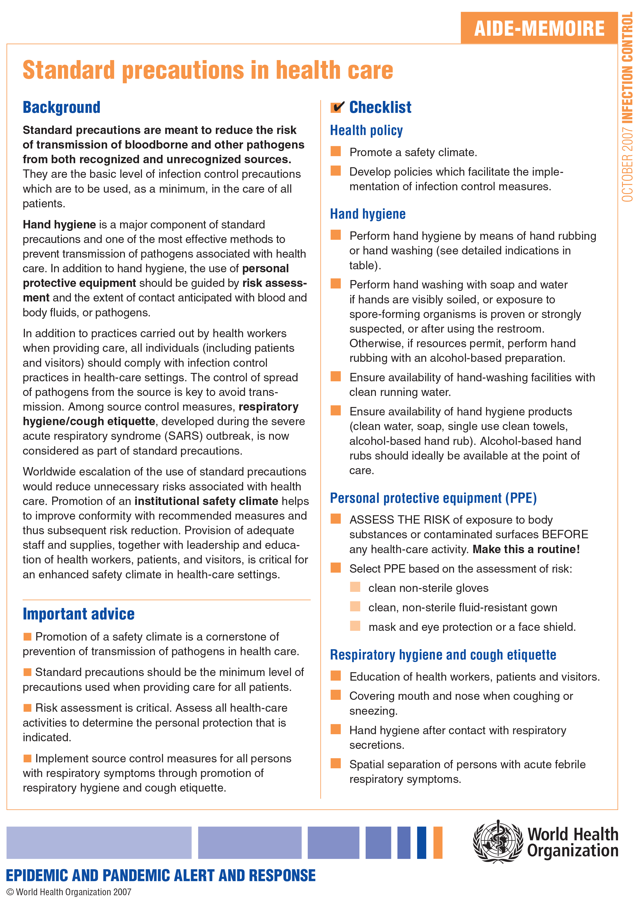
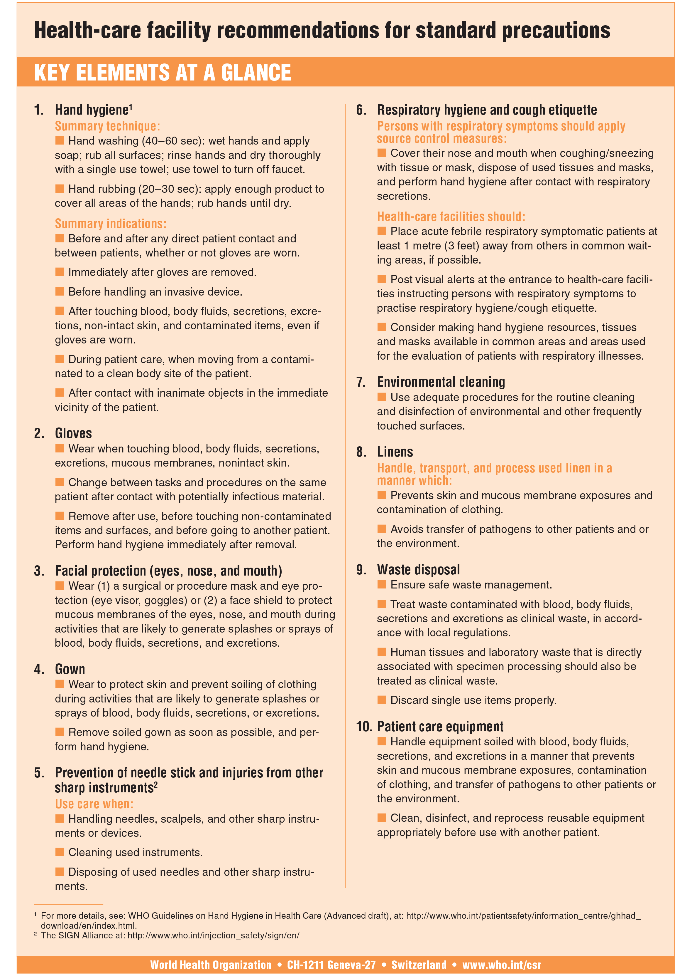

Appendix C: Research article relating risk assessment for Standard Precautions
Dowding, D., Russell, D., Trifilio, M., McDonald, M. V., & Shang, J. (2020). Home care nurses’ identification of patients at risk of infection and their risk mitigation strategies: a qualitative interview study. International journal of nursing studies, 107, 103617.

Abstract
Background
There is an increase in the number of individuals who receive care at home. A significant proportion of these patients acquire infections during their care episode. Whilst there has been significant focus on strategies for infection prevention and control in acute care environments, there is a lack of research into infection prevention in a home care setting.
Objectives
To understand (1) if and how home care nurses identify patients at high risk of infection and (2) the strategies they use to mitigate that risk.
Design
A qualitative descriptive study, using semi-structured interviews.
Setting
A large not for profit home care agency located in the New York region of the United States.
Participants
Fifty nurses with a range of experience in home care nursing.
Methods
Purposive and snowball sampling was used to recruit nurses from across the home care agency with varied years of work experience. Interviews were audio recorded and transcribed. The interviews explored how home care nurses evaluate their patients’ risk of developing an infection and if/how they modify the plan of care based on that risk. Data were analysed using thematic analysis.
Results
Three themes were derived from the data; assessing a patient's risk of infection, the risk assessment process, and strategies for mitigating infection risk. Factors identified by nurses as putting a patient at higher risk of infection included being older, having diabetes, inadequate nutrition; along with inadequate clinical information available at start of care. The patient's knowledge and understanding of infection prevention, and the availability and knowledge of caregivers were also important, as was the cleanliness of the home environment. Given the context of home care, where nurses have little control over the environment and care processes in-between visits, the main strategy for infection prevention was patient and caregiver education. Nurses also discussed the importance of their own infection prevention behaviours, and the ability to adjust a patient's plan of care according to their infection risk.
Conclusions
The study highlights the complexity of the risk assessment process in relation to infection. Existing guidelines for infection prevention and control do not adequately cover the home care environment and more research needs to determine which interventions (such as patient/caregiver education) would be most effective to prevent infections in the home care setting.

Appendix D: Promotional posters for optimal glove use

