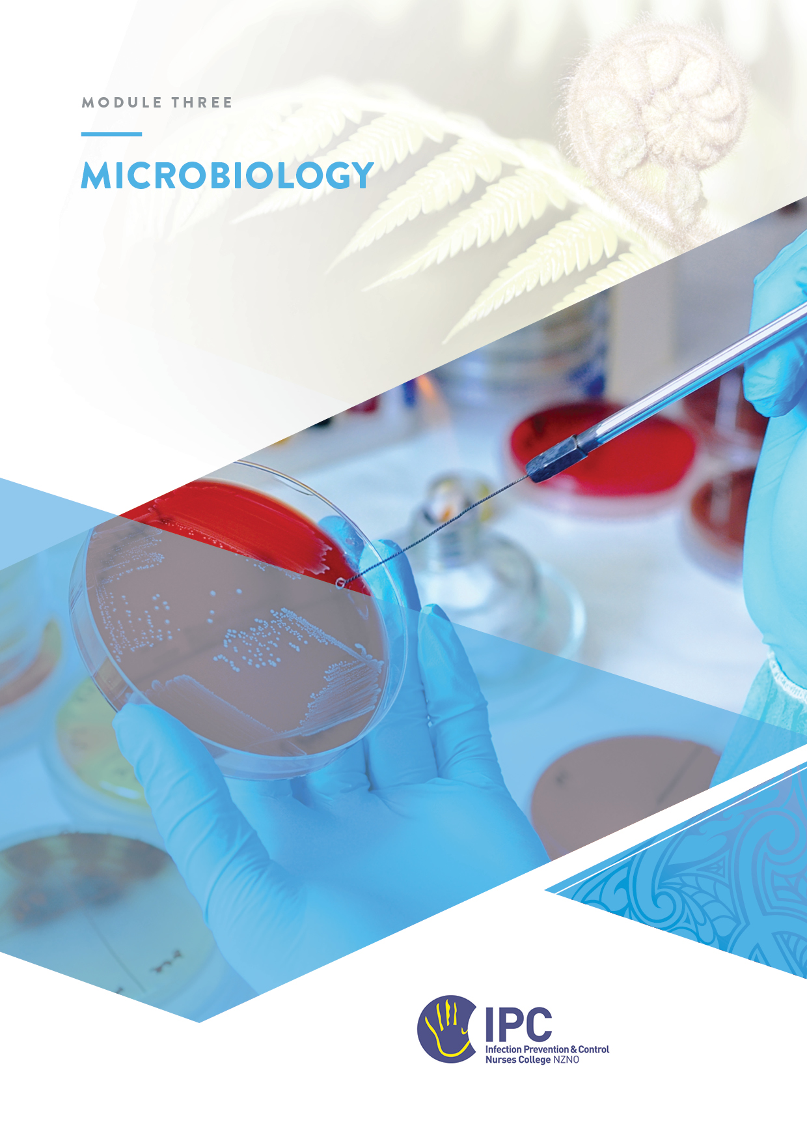

Microbiology
Table of Contents
Objectives 3
Online texts and resources 3
Instructions 3
Overview 4
Historical context of microbiology 4
Key Concepts 5
Resident flora 5
Microbiome 6
Types of living organisms 6
Bacteria 7
Classification of bacteria 7
Applying bacteria classification to diagnose the cause of infection 9
Bacteria of interest 9
Virology 11
Basic characteristics of viruses 11
Viruses of interest 12
Fungal infections 13
Parasites 14
How pathogens make us sick 15
Stages of Illness 16
The immune system 16
The microbiology laboratory 17
Testing for bacteria 17
Microbiology specimen collection and transportation 18
Interpretation of microbiology laboratory results 19
Urinalysis 19
The virology laboratory 20
Testing for viruses 20
Virus isolation methods 20
Whole Genome Sequencing (WGS) 21
Documentation and Reporting 22
Information for laboratory staff 22
Laboratory reporting mechanisms to IPC 22
Public Health and Forensic Science 23
Antimicrobial resistance 23
New Zealand’s approach to AMR 24
Antimicrobial stewardship 25
AMS in your facility 26
Clinical Microbiology Laboratory Experience (Optional) 27
Discussion with laboratory staff 27
Observation of procedures 27
Viewing of specific organisms on slides/plates 28
Appendix 1: Common Normal Flora 29
Appendix 2: Reviewing and Interpreting Culture Results 30
Appendix 3: Sample chart for antibiotic choice 31

Objectives
At the completion of this module, you will:
- Describe basic elements of microbiology relevant to infection prevention and control (IPC)
- Identify and interpret microbiology laboratory tests which have an impact on IPC
- Provide information about specimen collection
- Appreciate the importance of antimicrobial resistance

Online texts and resources
- Microbiology Nuts and Bolts: https://microbiology-nuts-and-bolts.weebly.com/
- CDC Diseases and Conditions https://www.cdc.gov/health-topics.html - choose a disease (for example mumps), then go to Laboratory Testing for lab tests used to diagnose mumps
- Ministry of Health Antibiogram Information
- Awanui Labs ‘Tests’ describes the range of tests available including those for a Blood and Body Fluid exposure in the NZ context
- Awanui Labs Prepare for My Test : describes the requirements for a range of specialised tests including for TB, sputum, and urine cultures from the patient perspective
- History of the science of microbiology https://www.youtube.com/watch?v=2JdBH2tys6M
- New Zealand Institute for Public Health and Forensic Science (PHF Science) Digital Library for public health, virology and bacteriology reports: https://www.phfscience.nz/digital-library/
- NZ Ministry of Health: Antimicrobial resistance. https://www.health.govt.nz/search?query=Antimicrobial+resistance

Instructions
- Read the material.
- Complete the answers to the questions and send the workbook to your mentor.
- Discuss any questions as required with your mentor.

As a component of this module, where possible, it is useful to have the opportunity to visit a microbiology laboratory. If you need further clarification on the exercises, you can bring them to discuss with laboratory staff. However, this is optional and it is not necessary to have completed a lab visit prior to submitting the module.

Overview
Hospital infection prevention and control (IPC) programs rely extensively on diagnostic microbiology laboratory testing. The role of the laboratory is essential for infection surveillance, in the management of antimicrobial resistance, and in outbreak investigation.
It is essential to have a basic understanding of microbiological terms and organisms in order to interpret laboratory information in the IPC context. A knowledge of the basic characteristics and properties of microorganisms will allow you to identify the mode of transmission and use this to inform and implement appropriate IPC measures.

Historical context of microbiology
Infection prevention and control practices have been used to prevent diseases as long ago as 2000 BC when some cultures burnt the clothes of a person who was suffering from an infectious disease. However, Medicine, including microbiology, was only recognised as a scientific discipline in the nineteenth century.
Several scientists and doctors were influential in advancing this science, developing and proving theories which added to the growing body of knowledge sometimes referred to as the ‘Germ Theory’. Use the resources below or other sources to answer the questions on the following page.
Resources
A short video providing an introduction to the historical background to Microbiology: Micro-Biology: Crash Course History of Science https://www.youtube.com/watch?v=2JdBH2tys6M

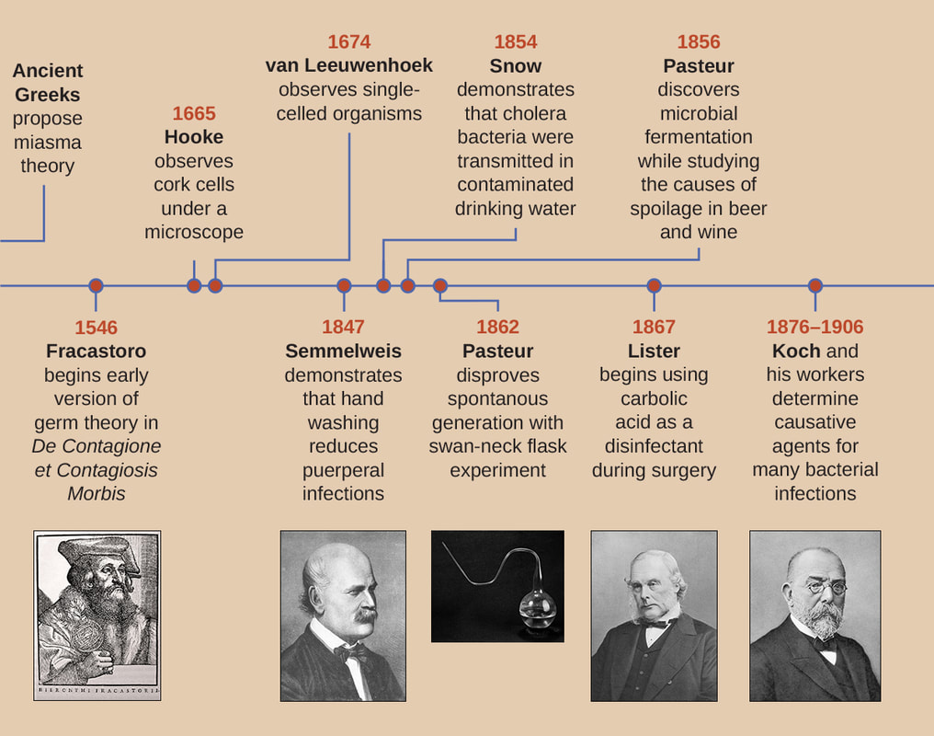
List three scientists in the nineteenth century and the work they are known for
Scientist | Contribution to the Germ Theory
What was the word used to describe the bad air and smells attributed to disease in the 18th century?

Key Concepts
Microbiology is the study of microscopic organisms. The term microorganism or microbe is used to describe any plant or animal which is too small to be seen with the naked eye and requires the use of a microscope. Microorganisms are classified in order of decreasing complexity: algae, fungi, protozoa, bacteria, mycoplasma, rickettsia, chlamydia and viruses.
Microbes are usually single-celled although fungi can be considerably more complex.

Resident flora
Most microorganisms live independently of humans or are either harmless or mutually beneficial. In fact, only around 50 species are actually harmful or pathogenic. In humans, normal microbial flora are important in maintaining our health, but may also cause disease at times.
What is the name of the yeast that can cause ‘thrush’ when the body’s microbial flora is disrupted through the use of steroids or antimicrobial therapy?

Infection is the presence of microorganisms causing damage to body tissues, usually in the presence of acute inflammation (pain, swelling, redness, heat and loss of function).
Colonisation describes when bacteria grow on body sites exposed to the environment, without causing infection. This is a normal process. These bacteria may form part of the normal flora of the individual. Colonisation does not normally harm the patient and does not usually need treating with antibiotics.
Use the resources below to complete the table on the next page.
Resources
- Normal Flora of the Human Body - LibreTexts™ accessed HERE
- Appendix 1: Common Normal Flora
List two bacteria that are usually normal flora, where they normally reside, and the type of infection that they can cause if disrupted. One example has been provided.
Bacteria that may be normal flora | Usual place found on the body | Type of infection these bacteria can cause
- E.Coli | Large intestine | Urinary tract infection

Microbiome
The microbiome is the collection of all microbes, such as bacteria, fungi, viruses, and their genes, that naturally live on our bodies and inside us. They protect us against pathogens, help our immune system develop, and enable us to digest food to produce energy.
The human microbiome is diverse, and each body site – for example, the gut, skin, and oral and nasal cavities – has a different community of microbes.
A person’s core microbiome is formed in the first years of life but can change over time in response to different factors including diet, medications, and environmental exposures.
In recent years the gut microbiome has been recognised as playing an important part in health. Watch the video below to understand the relationship between these microbes and determinants of health.
Resource:
What is the gut microbiome? (Washington Post) https://www.youtube.com/watch?v=d-Ln9NNj2KY

Types of living organisms
All living organisms can be grouped into two types based on their fundamental cell structure. They are prokaryotes and eukaryotes, and the cells they possess are called prokaryotic cells and eukaryotic cells. Prokaryotic cells are simpler than eukaryotic cells.
Pathogenic microbes can be prokaryotic or eukaryotic.
Many of the important pathogens affecting humans are bacterial. Pathogenic bacteria are prokaryotic cells.
Eukaryotic microorganisms which are harmful for humans include protozoa and fungi.

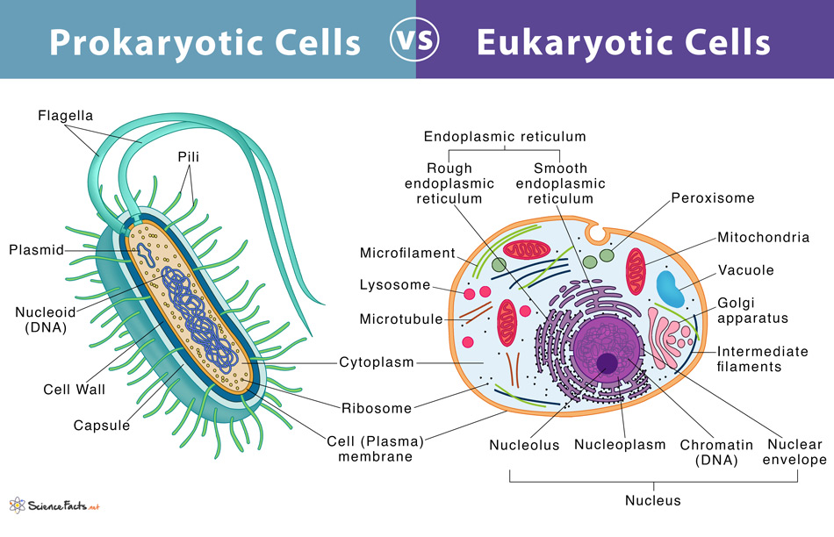

Bacteria
Resources
https://www.livescience.com/51641-bacteria.html
http://www.microbiologynutsandbolts.co.uk/basic-bacterial-identification.html

Classification of bacteria
Bacteria vary in size from 0.4-2 um. Bacteria can be classified according to their shape (morphology), Gram stain (the nature of their cell walls), or by their growth requirements.

Shape
Bacteria come in basic shapes: spherical, cylindrical, comma-shaped, corkscrew and spiral. The scientific names for these shapes are cocci (round), bacilli (cylindrical), vibrios (comma-shaped), spirochaetes (corkscrew) and spirilla (spiral).
- Cocci (spherical) – usually round but may sometimes be irregularly shaped. Cocci that remain in pairs are after dividing are called diplococci and those that remain attached in a chain are called streptococci while those that remain attached in clusters or broad sheets are called staphylococci.
- Bacilli (rod shaped/cylindrical) – most appear as single rods and may be uniform in shape although some are oval and look so much like cocci that they are called coccobacilli.
- Spirochetes (spiral shaped/corkscrew) – vary in length and in number of turns.
- Spirilla (spiral)
- Pleomorphic – lack a distinct shape (like jelly).

Gram staining
The cell wall also makes Gram staining possible. Gram staining is a method of staining bacteria involving crystal violet dye, iodine, and the counterstain safranin.
Many bacteria can be classified into one of two types: gram-positive, which show the stain and appear violet in color under a microscope, and gram-negative, which only show the counterstain, and appear red.
A different staining method called a Ziehl-Neelson stain uses an acid fast stain technique which stains red if the bacteria have mycolic acid in their cell wall. The ZN test is used to identify mycobacteria.

Growth requirements
A third way to classify bacteria is to describe their growth requirements for oxygen:
- Aerobic – grows in the presence of oxygen
- Anaerobic – grows in the absence of oxygen
- Facultative anaerobe – able to grow in the presence or absence of oxygen
- Microaerophilic – grows in the presence of oxygen at lower concentrations than air.

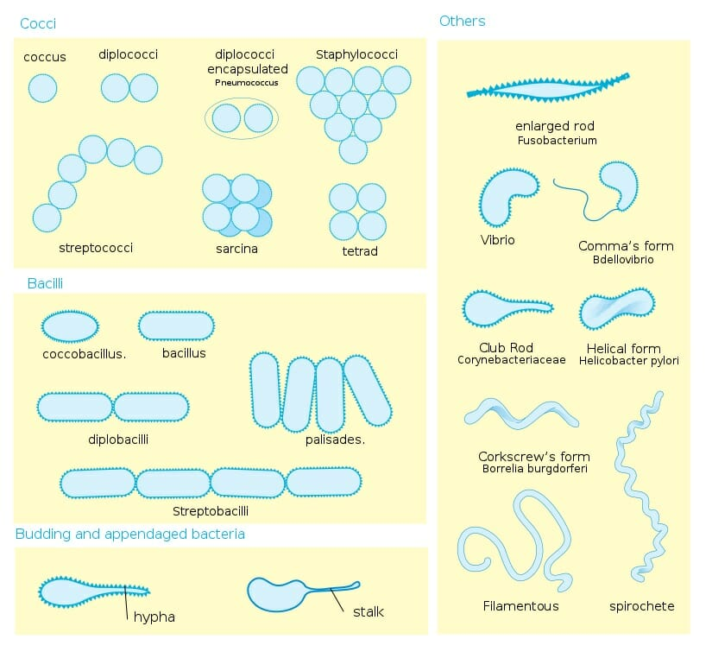
Figure 1: Bacteria shapes (morphology)

Applying bacteria classification to diagnose the cause of infection
The different bacteria characteristics and simple classification system can help identify the most likely cause of the infection. Firstly, identifying the staining method, then the shape of the microorganism and finally the microorganism’s growth requirements, a doctor can begin to eliminate microorganisms, like in a game of Cluedo.
The following clinical example demonstrates how the bacterial characteristics can be used to determine which type of antibiotics will be useful.
The patient clinically has septic arthritis:
- the Gram film of the synovial fluid shows Gram-positive cocci in clumps.
- Septic arthritis is caused by Staphylococcus aureus, Beta-haemolytic Streptococcus, Escherichia coli and Enterobacteriaceae.
- As it is Gram-positive this rules out Escherichia coli and Enterobacteriaceae, which are Gram-negative.
- The microscopy also states clumps, which rules out Streptococcus sp. as these form chains.
- This leaves Staphylococcus aureus, a clump forming Gram-positive coccus.

Identify the key characteristics and infection/disease most commonly associated with the following bacteria. (Resource: https://microbiology-nuts-and-bolts.weebly.com/basic-bacterial-identification.html)
Bacteria | Shape (cocci, diplococci, bacilli) | Gram + or  Gram - | Common infection or disease
Staphylococcus aureus
Group A Streptococci (Streptococcus pyogenes)
Clostridium difficile
Klebsiella pneumoniae
Neiserria meningitides
Escherichia coli

Bacteria of interest
Bacteria of interest to the IPC practitioner are those that cause infection or disease. The table below lists common infections and the bacteria responsible.
Common Infections and the usual organisms that cause them
Infection/site | Common Organisms
Bronchitis | S. pneumoniae, H. influenzae, respiratory viruses
Device-related | Coagulase-negative staphylococci, Corynebacteria sp.
Endocarditis | S. viridans, S. aureus, Enterococci
Gastroenteritis | Salmonella sp., Shigella sp., Campylobacter sp., E. coli 0157:H7, viruses
Meningitis | H. influenzae, N. meningitides, S. pneumoniae
Pharyngitis | S. pyogenes, respiratory viruses
Pneumonia (community) | S. pneumoniae, H. influenzae, M. pneumoniae, C. pneumoniae, M. tuberculosis
Pneumonia (healthcare ) | Pseudomonas sp. S. aureus, Enterobacteriaceae
Septicaemia | S. aureus, S. pneumoniae, E. coli, Klebsiella sp., Salmonella sp.
Sinusitis | S. pneumoniae, H. influenzae, S. pyogenes, S. aureus
Skin | S. aureus, S. pyogenes, Candida sp., dermatophytes
Urinary Tract | E. coli, Enterococci, Candida sp., Klebsiella sp., Proteus sp.

Microbiological testing in the environment
Testing the healthcare environment for pathogens is not recommended but may be undertaken in certain circumstances as part of an outbreak investigation, e.g. testing surfaces or handwash basins. Other instances when testing for environmental bacteria that may pose an infection risk includes:
- Quality assurance testing for microorganisms following endoscope reprocessing
- testing for increased aspergillosis in the air during construction located near high-risk patients
- Regular testing of the water from a cardiac bypass machine
Each facility should have a process to interpretate the significance of and subsequent actions to take for any positive environmental sampling results. This may require expertise input e.g. microbiologist, infectious diseases, senior IPC practitioner.

List any environmental microbiology testing routinely undertaken in your facility.

Virology
Resources
https://theconversation.com/what-is-a-virus-how-do-they-spread-how-do-they-make-us-sick-133437

Basic characteristics of viruses
A virus is a microorganism that is smaller than a bacterium. It cannot grow or reproduce apart from a living cell. A virus invades living cells and uses their chemical machinery to keep itself alive and to replicate itself. It may reproduce with fidelity or with errors (mutations); this ability to mutate is responsible for the ability of some viruses to change slightly in each infected person, making treatment difficult.
Viruses cause many common human infections and are also responsible for a number of rare diseases. Examples of viral illnesses range from the common cold which can be caused by one of the rhinoviruses, to AIDS which is caused by HIV.
Viruses may contain either DNA or RNA as their genetic material.
- Herpes simplex virus and the hepatitis B virus are DNA viruses.
- RNA viruses have an enzyme called reverse transcriptase that permits the usual sequence of DNA-to-RNA to be reversed so that the virus can make a DNA version of itself. RNA viruses include HIV and hepatitis C virus.
Researchers have grouped viruses together into several major families, based on their shape, behaviour, and other characteristics.
DNA viruses | RNA viruses
Herpes viruses | Picorna-viruses (including the rhinoviruses)
Adenoviruses | Calciviruses
Papovaviruses (including the papillomaviruses) | Paramyxoviruses
Hepadnaviruses | Orthomyxoviruses
Poxviruses | Rhabdoviruses
Parvoviruses | Filoviruses
 | Retroviruses

There are dozens of smaller virus families within these major classifications. Many viruses are host specific, capable of infecting and causing disease in humans or specific animals only.
Resources:
TABLE 201.3 in ‘Chapter 201 - Classification of Human Viruses’ - accessed HERE.
Virology – the basics https://www.ogmagazine.org.au/17/2-17/virology-guide-basics/ - Tables 1&2

Give an example of a virus and its associated disease/infection from the following virus families.
Family | Virus causing infection | Infection or disease
Coronavirus
Herpes viruses
Filovirus
Retrovirus

Viruses of interest
Viruses frequently cause outbreaks and are responsible for many pandemics including COVID-19. They vary in their infectivity and modes of transmission. Some viral diseases are seasonal. Non-enveloped viruses are more difficult to kill with disinfectants.
Complete the table below.
Virus | Enveloped or non-enveloped | Type of transmission-based precautions | Other IPC considerations
Influenza virus
SARS CoV-2
Measles virus
Respiratory Syncytial Virus (RSV)
Norovirus

You may be asked to review results for hepatitis B virus testing e.g. as part of occupational health staff screening or follow-up of a blood exposure. In most instances patients who are tagged as hepatitis positive do not require additional precautions and can be cared for with standard precautions. However, in renal dialysis units, Hepatitis positive patients usually require additional precautions e.g. dedicated dialysis machine.
Interpret the following results for hepatitis B virus testing:
Resource: CDC Interpretation of Hepatitis serology - Interpretation of Hepatitis B Serologic Test Results
Disease | Tests | Results | Interpretation
Hepatitis B | HBsAg | Negative
Hepatitis B | Anti-HBc | Negative
Hepatitis B | Anti-HBs | Negative
Hepatitis B | HBsAg | Negative
Hepatitis B | Anti-HBc | Negative
Hepatitis B | Anti-HBs | Positive with ≥ 10 IU/ml
Hepatitis B | HBsAg | Positive
Hepatitis B | Anti-HBc | Positive
Hepatitis B | IgM anti-HBc | Positive
Hepatitis B | Anti-HBs | Negative

There are some distinct differences between viruses and bacteria.

In the table below match the characteristic with either ‘viruses’ or ‘bacteria’:
Characteristic | Viruses or Bacteria
An electron microscope is used to see the organism
Usually tested for susceptibility to antibiotics
Has a cell wall and a cell membrane
Need a living host to multiply

Fungal infections
Fungal infections in humans are called mycoses:
- Fungal infections can be systemic or deep involving internal organs, especially the lungs.
- Subcutaneous or superficial mycoses grow in the deep or outer layers of the skin, hair and nails e.g. athlete’s foot.
- Opportunistic fungal infections only infect those who are already sick or with an immunodeficiency disorder.
Using the resource below provide examples of different types of fungal infections.
Resource: DermNet™ Introduction to fungal infections https://dermnetnz.org/topics/introduction-to-fungal-infections/

Type of fungal infection | Fungal infection
Systemic /deep
Superficial
Opportunistic

Parasites
A parasite is an organism that lives in or on and takes its nourishment from another organism. A parasite cannot live independently. Parasitic diseases include infections caused by protozoa, helminths, and arthropods:
- Protozoa – Malaria is an example of a disease caused by a protozoa, plasmodium protozoa, a single-cell organism that can only divide within its host organism
- Helminths – Schistosomiasis, another very important parasitic disease, is caused by helminths (worms) in the Schistosoma family. Roundworms, common in NZ, are also helminths
- Arthropods – The arthropods include mosquitoes and ticks, several of which can act as vectors (carriers) of parasitic diseases.

Giardia is a common parasitic disease in New Zealand.
Resources
Health New Zealand – Food and water-borne diseases - Giardia
Sepsis and Parasitic Infections (Sepsis Alliance 2024): https://www.sepsis.org/sepsisand/parasitic-infections/

Using the resources listed above, answer the following questions about Giardia in New Zealand.
Question | Answer
What are two ways that Giardia can be caught in NZ? | 1.  2.
What are the symptoms of giardia infection?
What antibiotic is commonly used to treat Giardia?
Are there any IPC precautions to use in hospital with a patient with confirmed Giardia infection?

How pathogens make us sick
Infection does not necessarily lead to disease. Infection occurs when viruses, bacteria, or other microbes enter your body and begin to multiply. Disease, which typically happens in a small proportion of infected people, occurs when the cells in your body are damaged as a result of infection, and signs and symptoms of an illness appear.
In response to infection, your immune system springs into action. White blood cells, antibodies, and other mechanisms go to work to rid your body of the foreign invader. Indeed, many of the symptoms that make a person suffer during an infection—fever, malaise, headache, rash—result from the activities of the immune system trying to eliminate the infection from the body.
Pathogenic microbes challenge the immune system in many ways.
- Viruses make us sick by killing cells or disrupting cell function. Our bodies often respond with fever (heat inactivates many viruses), the secretion of a chemical called interferon (which blocks viruses from reproducing), or by marshalling the immune system’s antibodies and other cells to target the invader.
- Many bacteria make us sick the same way, but they also have other strategies at their disposal:
  - Bacteria multiply so rapidly they crowd out host tissues and disrupt normal function.
  - Bacteria kill cells and tissues outright.
  - Bacteria can make toxins that can paralyze, destroy cells’ metabolic machinery, or precipitate a massive immune reaction that is itself toxic.
The bacterial cell wall performs several functions as well, in addition to providing overall strength to the cell. It also helps maintain the cell shape, which is important for how the cell will grow, reproduce, obtain nutrients, and move. It protects the cell from osmotic lysis, as the cell moves from one environment to another or transports in nutrients from its surroundings.

Stages of Illness
Rearrange the definitions in column 2 to correspond with the correct stage of illness in column 1.
Stage of illness | Definitions
1. Invasion | - maximum impact of illness when pathogen is proliferating rapidly – toxic by-products of microbial metabolism and immune response produce tissue damage
2. Incubation | - pathogen replicating, no symptoms
3. Prodromal | - pathogen acquires entry into the body e.g. by mucous  membrane inhalation, self-inoculation
4. Acute illness | - pathogen is contained and eliminated from body, damaged tissue is repaired and resolution of symptoms
5. Recovery | - initial appearance of symptoms (usually mild and vague)

The immune system
The immune system is made up of special organs, cells and chemicals that fight infection. The main parts of the immune system that actively fight infection are: white blood cells, antibodies, the complement system, the lymphatic system, the spleen, the thymus, and the bone marrow.
Resources:
The immune system explained – Bacterial Infection video https://www.youtube.com/watch?v=zQGOcOUBi6s
Immune system explained (BetterHealth Victoria State Government HERE

List three types of white blood cells important for the immune system
1.
2.
3.

Describe how these body processes protect or respond to infection:
Body’s process | Description of how it protects or responds to infection
Antibodies
Skin
Lungs
Digestive tract
Fever

The microbiology laboratory
Resources
IFIC Journal article. The role of microbiology laboratory in healthcare-associated infection prevention. S Kalenić, A Budimir. Int. J. Infect. Control, 2009
The microbiology department is an essential component of IPC practice. The laboratory is necessary to diagnose infection but can also play a part in supporting IPC activities.
Diagnosis is dependent on the correct sample being taken, the correct transportation of the sample and the inclusion of relevant and important information on the request form.

Testing for bacteria
Resources
https://dermnetnz.org/topics/laboratory-tests-for-bacterial-infections/
‘A Guide to Bacterial Culture Identification And Results Interpretation’ - https://www.ncbi.nlm.nih.gov/pmc/articles/PMC6428495/
A number of laboratory tests can establish or confirm the presence of a bacteria. Different approaches to early bacterial identification include Gram staining, matrix-assisted laser desorption/ionization time of flight mass spectrometry (MALDI-TOF), PCR, nanoparticle probe technology, and peptide nucleic acid fluorescence in situ hybridization (PNA-FISH).
The culture of the bacterial species with antibiotic sensitivity testing is considered the gold standard laboratory test.
List three other different bacteria tests that may be used (refer to first resource above)
1.
2.
3.

Give explanations for the following questions.
Explanation
What is the most common type of agar used for culture?
What is a colony forming unit (CFU) and how are they counted?
How are antibiotic sensitivities tested?

Microbiology specimen collection and transportation
Specimen collection and transport to the lab is an essential part of the culture process. In general, all specimens should be collected aseptically and placed in a sterile container; in some cases, specimens are put into culture media directly (for example, blood cultures).
Prompt delivery to the laboratory is essential to prevent the death of pathogenic organisms or the overgrowth of commensal organisms (that live on, or in certain parts of, the body, without causing disease). If transport is delayed, some specimens may be refrigerated (for example, urine, stool, and sputum specimens) while others should be maintained at room temperature (for example, genital, eye, or spinal fluid specimens).
Specific procedures for specimen collection and transport may be institution dependent. Please refer to your local laboratory manual for specific procedures and protocols.

Complete this table following your local laboratory protocols:
Test | Important points on collection of the specimen including any common problems with collection and transportation to the lab
Blood culture
Wound culture
Urine culture
Stool for C. difficile
Throat culture
Sputum culture

Interpretation of microbiology laboratory results
If possible find 2 or 3 different microbiology laboratory results and look at the information provided. Does it provide useful information for you as an IPC practitioner? Consider the following information and comment on how it may be useful.
Information | Why is this useful / what is the significance?
Type of specimen
Date reported
Gram stain
Mixed growth
Cell count (CFU)
Organism
Sensitivity/resistance

Urinalysis
Urinary tract infections are one of the most common infections treated. Urinalysis is the most frequently used test for the evaluation of potential urinary tract infection (UTI). The table below provides an overview of a typical laboratory urinalysis (Reference).
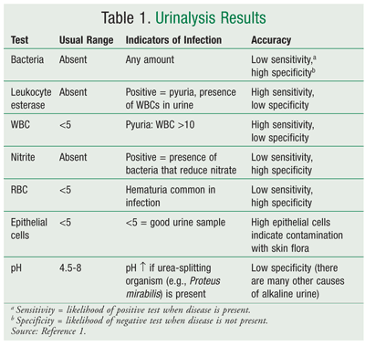
A urinalysis dipstick is often used as a point-of-care test to help diagnose an UTI. While the results may be useful in some situations the dipstick is unreliable in in the elderly and should not be used alone to diagnose or initiate antibiotics for a UTI.
The Health Quality and Safety Commission has several on-line resources for clinicians to manage UTIs:
- Urinary tract infections | Te pokenga pūaha mimi (Frailty care guides 2023) – available HERE
- ‘Guide to improving the use of antibiotics in the management of urinary tract infections in aged residential care’ - available HERE
You can also read the article below to understand why using a dipstick in care of the elderly is not recommended.
‘Time to dip the urinalysis test strips in the bin’ - https://www.cgakit.com/urine-dipstick

The virology laboratory
Resources
Laboratory tests for viral infections - https://dermnetnz.org/topics/laboratory-tests-for-viral-infections/
Virology – the basics https://www.ogmagazine.org.au/17/2-17/virology-guide-basics/
Virology diagnostic tests Medical viruses: diagnostic techniques
Virus tests - a simple guide (My Health Alberta, Canada)

Testing for viruses
There are four categories of diagnostic tests for viruses:
- serology: demonstrating an antibody response in a patient's serum
- direct detection of viral antigens in a clinical sample
- virus culture
- viral nucleic acid detection

Virus isolation methods
- Cell culture can take a long time, is not used often.
- Serology methods for antibody detection:
Serology forms the mainstay of viral diagnosis. Following exposure, the first antibody to appear is IgM, which is followed by a much higher titre of IgG. Detection of rising titres of antibody between acute and convalescent stages of infection, or the detection of IgM in primary infection are often used for diagnosis of viral infections.
Watch this video for an explanation of IgM and IgG with COVID-19 infection: https://www.youtube.com/watch?v=0ztF-419fac

- Other virology tests

Complete this table
Test method | Give examples of a viral disease where this testing is used
Enzyme-linked immunosorbent assay (ELISA)
Immunofluorescence
Polymerase chain reaction (PCR) assay

Whole Genome Sequencing (WGS)
Whole-genome sequencing (WGS) is the analysis of the entire genomic DNA sequence of a cell at a single time, providing the most comprehensive characterization of the genome. It is a more recent laboratory technique used in outbreak management.
The technique has been applied to estimate the timing and directionality of transmission of a pathogen and to exclude cases from an investigation. It has been used for bacterial and viral outbreaks in public health and healthcare settings.

Resources
Detecting Outbreaks with Whole Genome Sequencing - CDC: Advanced Molecular Detection of Outbreaks
Using WGS to combat COVID-19 - https://www.phgfoundation.org/blog/wgs-to-combat-COVID-19

Describe how WGS can help determine the extent of a MRSA outbreak investigation where multiple cases have been found in different wards/units.

Documentation and Reporting

Information for laboratory staff
The microbiology laboratory requires and uses different information for their processes.
Describe the laboratory significance of the following information that is provided on the request form:
Criteria | Laboratory significance
Date and time collected
Diagnosis
Person ordering the test
Source of the specimen, leg, vagina, etc.
Type of sample taken e.g. wound swab, pus, MSU, clean catch
Current antimicrobial therapy of patient

Incorrect information or not enough information is a common problem with laboratory requisition forms and orders.

Have you any suggestions how this problem might be improved at your facility?

Laboratory reporting mechanisms to IPC

Answer the following questions about how laboratory reports are managed by IPC in your facility. If your facility does not receive laboratory reports, consider if this would be useful e.g. during an outbreak
Reporting | Answer
How often does IPC receive lab results e.g. daily/weekly/ never?
Which lab reports are received?
What is the process for IPC to receive MDRO, TB or C.diff reports?
Which results are used for the IPC surveillance programmes?
Are MDRO results entered onto a database?
Is there an ‘alert’ system to identify patients / residents who are colonised or infected with multi-resistant microorganisms?

Public Health and Forensic Science
The New Zealand Institute for Public Health and Forensic Science (PHF Science) is the New Zealand government research agency whose function is to monitor disease, test food and products, safeguard our water, support the justice sector and more.
PHF Science can undertake further testing on laboratory samples sent to them to assist with outbreaks or surveillance findings.
The PHF Science Digital library provides several dashboards and regular reports for pathogens or diseases of public health importance. Examples include a Measles dashboard; Laboratory-based virology weekly report - 2024 Week 16. The digital library also has older MDRO reports.
Access the digital library via this link https://www.phfscience.nz/digital-library/. Scroll through the reports and answer the question below.
Which multi-resistant organism (MDRO) is reported via a line listing on the PHF Science digital library site?

Antimicrobial resistance
Antimicrobial resistance is a global health threat and it is getting worse. The term antimicrobial resistance (AMR) refers to resistance by different types of microorganisms to antibacterial, antiviral, antiparasitic and antifungal drugs.

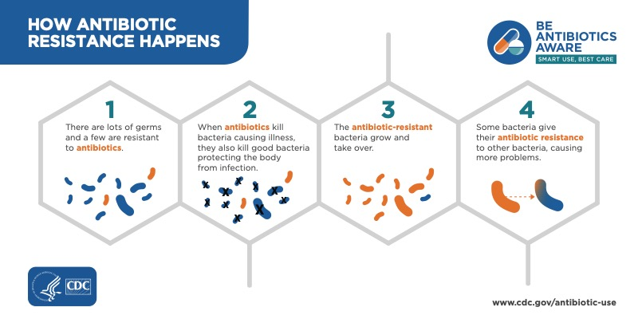

Antibiotic resistance occurs when bacteria evolve to evade the effect of antibiotics through multiple different mechanisms commonly categorized into the following four groups:
- Intrinsic resistance
- Acquired resistance
- Genetic change
- DNA transfer

Ways that this works are described below:
- Certain bacteria are able to neutralize an antibiotic by altering its component to render it ineffective.
- Others might be able to export the antibiotics out of the bacteria.
- Some can modify their outer structure and receptors so that antibiotics cannot attach to them. These mechanisms might lead to some bacteria surviving the use of the specific antibiotic and developing a resistance that can be passed to other bacteria as they multiply.
- Bacteria also can become resistant through mutation of their genetic material.

New Zealand’s approach to AMR
Although rates of AMR are comparatively low in New Zealand, we still have a responsibility to minimise AMR through good antimicrobial resistance stewardship (AMS).
Our overarching healthcare standard Ngā Paerewa health and disability services standard includes criteria for an AMS programme.
New Zealand has an Antimicrobial Resistance Action Plan, published in 2017 and available HERE.
Access the document above and answer the question:
What are the five key objectives of the NZ AMR Plan?
1.
2.
3.
4.
5.

Antimicrobial stewardship
Antimicrobial stewardship is a coordinated program that promotes the appropriate use of antimicrobials (including antibiotics), improves patient outcomes, reduces microbial resistance, and decreases the spread of infections caused by multidrug-resistant organisms.
The Australian Commission on Safety and Quality in Healthcare has published a AMS Clinical Care Standard summarised in a fact sheet available HERE.
Infection prevention and control (IPC) is key to reducing demand for antimicrobial use and reducing the acquisition of antimicrobial resistance. Poor IPC can increase the spread of drug-resistant infections.
All healthcare workers have a responsibility towards AMS, not just prescribers. Nurses have a key role to play in many areas relevant to AMR, including:
- promoting and practising standard precautions including hand hygiene and other infection prevention and control measures
- recognising signs and symptoms of infection
- initiating clinical assessment and review
- ensuring that timely specimens for microbiology are collected correctly
- promoting the use of prescribing guidelines
- providing information and support to patients and their families about their health condition, treatment options, and how and why to take medicines according to the doctor’s instructions
- medication administration and management
- ensuring treatments are recorded properly in the patient’s health record.

Click on this link to do a quick AMR quiz: https://www.emro.who.int/waaw2018/quiz/amr/index.html

AMS in your facility

List ways that your organisation / facility puts antimicrobial stewardship into practice

Clinical Microbiology Laboratory Experience (Optional)
If possible, follow a specimen from the time it is received in the laboratory until the report is finalised and sent to the ordering health professional.

Discussion with laboratory staff
Item | Notes
Get an understanding of how lab work is divided
How long different tests take and why
The differences in the type of media for different tests
How contamination of the specimens is avoided
Tests for identifying organisms
Review antibiotic sensitivity testing
How are reports generated

Observation of procedures
Observe the following procedures:
Procedures | Notes
Gram stain
Sensitivity method
Blood culture
Specimen for AFB
Urine culture
Wound culture

Viewing of specific organisms on slides/plates
View the following slides/plates: | Comments
Staphylococcus aureus
Streptococcus pneumoniae
Mycobacterium tuberculosis
Neisseria meningitidis
Bordetella pertussis
Streptococcus pyogenes (Group A strep)
Fungi

Appendix 1: Common Normal Flora
Body Site | Common organisms
Mouth | Staphylococci, S. viridans, Enterococci, S. pneumoniae,  Neisseriae, Corynebacteria, Haemophilus,  Enterobacteriaceae, Actinomyces, Lactobacilli,  Bifidobacteria, Fusobacteria, anaerobic Gram neg. cocci, anaerobic Gram neg. cocci
Upper Respiratory Tract | Staphylococci, S. viridans, S. pneumoniae, Corynebacteria,  Haemophilus, Propionibacteria, Actinomyces, Bacteroides,  Fusobacteria, anaerobic Gram neg. cocci, anaerobic Gram neg. cocci
Skin | Staphylococci, Corynebacteria, Propionibacteria, anaerobic Gram neg. cocci
Conjunctiva | Staphylococci, Corynebacteria, anaerobic Gram neg. cocci
Lover Intestine | S. viridans, Enterococci, Corynebacteria, Enterobacteriaceae, Clostridia, Lactobacilli, Bifidobacteria, Fusobacteria, anaerobic Gram neg. cocci
External Genitalia | Staphylococci, S. viridans, Enterococci, Corynebacteria, Enterobacteriaceae, Bacteroides, Fusobacteria, anaerobic Gram neg. cocci
Anterior Urethra | Staphylococci, Enterococci, Neisseriae, Corynebacteria, Bacteroides, Fusobacteria, anaerobic Gram neg. cocci
Vagina | Staphylococci, S. viridans, Enterococci, Neisseriae,  Corynebacteria, Lactobacilli, Bifidobacteria, Bacteroides, anaerobic Gram neg. cocci

Appendix 2: Reviewing and Interpreting Culture Results

Specimens and culture results
- Gather as much information as possible!!
- Know what ‘normal flora’ is and what potential ‘pathogens’ are.
- Some specimen types such as sputum and faeces will always contain organisms as ‘normal flora’ and potential pathogens must be separated from them, for example, coughing up sputum will always be contaminated with saliva and potentially non-pathogenic organisms.
- Other specimens such as blood and CSF are normally sterile, so any growth needs to be evaluated.
- Is it clinically significant? (is the person sick with symptoms)
- Is it a contaminant? (skin contamination with blood collection)
- Is it a transient loss of sterility? (transient bacteremia after brushing teeth)
- Quantitative values – the quantity of organisms is expressed as colony forming units per litre (CFU/L) helps in identifying contamination from infection – used for urine testing, for example, counts > 100,000 usually considered a potential UTI.
- Number of positive cultures important, for example, the same organism isolated from blood specimen and another site suggests bacteraemia arising from infection at that site.
- Clinical findings important in interpreting cultures, for example, signs and symptoms of dysuria and frequency of urination as important as urine culture in diagnosing UTI.
- Person’s history important, for example, the presence of a prosthetic heart valve increases the likelihood of coagulase negative staphylococcus (CNS) in a blood culture representing endocarditis than when the person has no history of heart surgery.
- Keep in mind that some heavily colonised wounds will heal spontaneously, and conversely, some organisms are able to cause serious infection at much lower levels of colonisation. Infection depends on the pathogenicity of the organism, the type of wound, and the patient’s response.
- Person’s who are immunosuppressed, on steroids, or neutropenic have a greater chance of infection with ‘opportunistic pathogens’ e.g. aspergillus in the sputum of a neutropenic person has more serious implications than in a normal host.

Appendix 3: Sample chart for antibiotic choice

