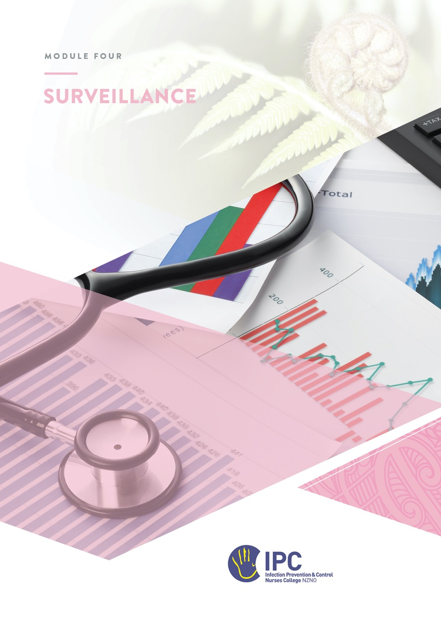
This module is kindly sponsored by:
Surveillance
Table of Contents
Objectives 2
Required readings 2
Recommended resources 2
Instructions 3
Overview 4
Key Concepts 5
Purpose of surveillance 5
Surveillance design and methods 5
Collecting surveillance and audit data 6
Surveillance case definitions 9
Data analysis 10
Feedback and reporting findings 11
Outbreak surveillance 11
Surveillance of multi-drug resistant organisms (MDRO) 11
Quality improvement 12
National surveillance programmes 12
Ethical Issues 13
Applying knowledge to practice 14
Review your organisation’s surveillance and/or auditing activities. 14
Quality improvement 17
Practice with data analysis 17
Reporting 17
Appendices 19
Appendix A - Surgical Site Infection (SSI) Surveillance Definitions: 19
Appendix B - Surveillance definitions for infections in aged residential care (ARC) 22
Appendix C - Calculating infection rates in long term care facilities 23

Objectives
At the completion of this module you will:
- Identify or design an infection surveillance and/or auditing programme within your organisation.
- Understand and apply concepts and methods of infection surveillance at a local and national level.
- Describe types of audits used to monitor compliance with infection prevention and control (IPC) practices.
- Provide examples of quality improvement arising from surveillance and/or audit activities.

Required readings
- Australian_guidelines_for_the_prevention_and_control_of_infection_in_healthcare_2024 Section 4.4. Healthcare associated infection surveillance.
- Australian Commission on Safety and Quality in Healthcare, Infection Prevention and Control Workbook, Module 5, Basics of surveillance and quality improvement (June 2024).
- Surveillance of health care-associated infections at national and facility levels: practical handbook. Geneva: World Health Organization; 2024.

Recommended resources
- Health New Zealand | Te Whātu ora Infection Prevention and Control – national surveillance programmes https://www.tewhatuora.govt.nz/health-services-and-programmes/infection-prevention-and-control#infection-prevention-and-control-ipc
- CDC/NHSN Surveillance definitions of healthcare-associated infection and criteria for specific types of infections in the acute care setting. https://www.cdc.gov/nhsn/pdfs/pscmanual/pcsmanual_current.pdf
- CDC/NHSN Outpatient Procedure Component – Surgical Site Infection (January 2025). Table 1, pages 4-5 provides suggestion for targeted surveillance in the ambulatory care / outpatient setting).
- Recommended practices for surveillance: Association for Professionals in Infection Control and Epidemiology (APIC). AJIC 2007. https://apic.org/Resource_/TinyMceFileManager/Practice_Guidance/AJIC-Surveillance-2007.pdf
- Stone, ND et al. Surveillance definitions of infections in long-term care facilities: revisiting the McGeer criteria. Infect Control Hosp Epidemiol 2012;33:965–977. https://pmc.ncbi.nlm.nih.gov/articles/PMC3538836/pdf/nihms430715.pdf
- Disease surveillance in office-based practice – Section 4.4.5 in Australian_guidelines_for_the_prevention_and_control_of_infection_in_healthcare_2024
- Surveillance for hospices and home care. Webber training slides Mohamed Adawee, 09 March 2023.

Instructions
- Read the material.
- Complete the answers to the questions and send the workbook to your mentor.

Overview
Infection surveillance is described as ‘’the ongoing, systematic collection, analysis, interpretation, and dissemination of data regarding a health-related event, for use in public health action to reduce morbidity, mortality and to improve health’’.
Audits are described as ‘’a quality improvement process that seeks to improve patient care and outcomes through systematic review of care against explicit criteria and the implementation of change’’.

In a healthcare facility, surveillance and audits have an important role in reducing healthcare-associated infections (HAIs), morbidity and mortality. Infection surveillance and audit programmes are used to collect data that can improve the quality of patient care through identifying a problem and implementing change which leads to improvement. Quality improvement approaches are used, and surveillance and audit activities are often incorporated into the organisation’s quality improvement programme.
John Snow who investigated the 1854 cholera outbreak in London is credited as the first epidemiologist to undertake public health surveillance in the UK. Using surveillance methods, he determined that contamination of a common drinking water pump was responsible for cross-infection of the disease.

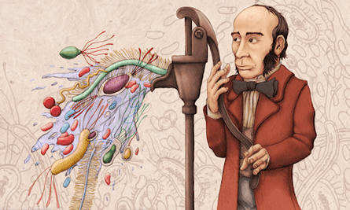
John Snow and the Broad Street pump. Illustration: Alexander Bertram Powell

The first recommendations for surveillance programs in hospitals was in the USA in the 1950s. Subsequently Haley’s sentinel Study of the Efficacy of Nosocomial Infection Control (SENIC) provided the earliest evidence of the impact of surveillance on reducing HAI rates.
Infection prevention and control (IPC) audits collect observation and/or documentation data about the physical environment or practices that are designed to reduce HAI. Examples of IPC audits include compliance with practices such as aseptic technique, ‘The 5 Moments for Hand Hygiene’ or correct setup for isolation, and audits of the physical environment in relation to IPC, such as environmental cleaning audits, or audit of correct placement for hand hygiene dispensers or sharps containers.
Infection surveillance and audits can identify where problems are so we can focus interventions to improve IPC practices and patient outcomes. Each infection surveillance or audit programme, e.g. surgical site infections (SSI), post procedure infections, or hand hygiene compliance, should have a clear purpose and specific objectives. This focuses data collection and analysis and helps engage the senior management team!

Key Concepts
Key concepts refer to the basic information that someone working in IPC will require in order to undertake surveillance effectively.

Purpose of surveillance
It is important that each surveillance or audit activity has a clear purpose or aim that all stakeholders understand. Specific objectives for each programme may also be used to guide quality improvement measures e.g. to attain an 80% hand hygiene compliance rate.
Using any of the three required readings on Page 2, describe the main purpose of surveillance or audit.
What is the main purpose of surveillance or audit?

Surveillance design and methods
There are many different types of surveillance approaches, each of which has strengths and limitations. It is important to decide which approach will best suit your surveillance programme’s purpose and objectives.
Choosing a surveillance method for your organisation will consider its purpose, how long the surveillance will last, the resources available, the services provided and the patient population and risk factors for infection. These factors will vary between different types of service providers such as aged residential care, acute public hospitals, private surgical hospitals, and day surgery facilities. All organisations that provide healthcare services should have an infection surveillance or monitoring programme in place. This publication provides practical guidance on setting up a surveillance programme and plan.
Surveillance can measure either processes or outcomes.
- Processes are activities that are typically performed by a healthcare provider at some point during the course of patient care e.g. hand hygiene. Process surveillance involves auditing practice against a certain standard, guideline or policy
- Outcomes refer to the results of care e.g. the number of orthopaedic SSI. Outcome surveillance measures these adverse events. Other outcome measures may include HAI Staphylococcus aureus bacteraemia, catheter-associated urinary tract infections.

In the required reading, Table 5.1 of the ACSQH Workbook, Module 5 provides a comprehensive list of surveillance methods used for infection surveillance. The list includes both process and outcome methods. Using this reference complete the following tables in your own words.
Surveillance method | Advantages | Disadvantages | Example
Continuous
Targeted
Process
Signal (sentinel)
Active (screening)

What is the main difference between prospective and retrospective surveillance?

Collecting surveillance and audit data
Populations to target for infection surveillance
Surveillance should be performed for infections for which there are clear strategies that can be implemented for prevention and control of transmission. Similarly, audit activity should focus on processes and practices that may contribute to infection transmission.
Surveillance activities may need to target those infections in a facility that have the most potential for prevention.
- In the larger acute care settings, infection surveillance may include any national surveillance programmes, high-risk surgery SSI, urinary catheter-associated infection (CAUTI), infections associated with central venous access devices, HAI MDRO, or infections in critical care patients.
- In a residential care setting, infection surveillance targets may include residents with indwelling devices, respiratory infections, skin breakdown/infection. However, these facilities should also include infections associated with a high likelihood of transmission and development of outbreaks (e.g., norovirus, influenza, group A Streptococcus).
- In a private surgical hospital, infection surveillance targets may include clean surgery SSI, for example orthopaedics, cardiac or hernia surgery.
- In office-based practices, infectious disease surveillance in patients is important. Staff have a role responsibility for notification of any suspected or confirmed notifiable infectious disease. GP practices can also assist with post-discharge SSI surveillance. Generally a GP practice will not undertake enough surgical procedures for outcome surveillance.
Many audit activities are useful across most healthcare organisations including compliance with aseptic technique, hand hygiene practices, cleaning audits, compliance with isolation setup etc.
Consider what might be an appropriate surveillance or audit programme for each type of facility listed below and provide an example. Include whether this is a process or outcome measure.
Type of facility | Surveillance / audit e.g. hand hygiene, HAI MDRO | Process or outcome measure?
Large acute hospital
Aged residential care home
Hospice
GP practice
Private surgical hospital
Private day procedure facility

Identifying cases and data sources
Methods for identifying infection cases of interest or conducting audits must be thorough and consistent. Data collection procedures should include strategies for ensuring accuracy and completeness of data. Those collecting the surveillance and/or audit data must be trained in these processes.
It may be necessary to collect surveillance information from multiple sources such as post-discharge patient surveys, surgeon reports, chart review, laboratory results, and admission data. Use a standardised form so that the same information is collected for all cases. Similarly, when undertaking a process audit, use a standardised audit tool to collect your data.
For efficiency and ethical reasons, you should only collect the data that you need for analysis and reporting. For example, if the sole objective of a hand hygiene compliance programme is to report hand hygiene rates, then collecting supplementary information about ‘bare below the elbows’, glove use or wearing rings is not required unless you are also going to analyse and report those findings.
Complete the following table to help you summarise the strengths and limitations of the different options for collecting infection data to identify cases.
Source of information | Strengths | Limitations
Admission information
Patient/client notes
Patient observation charts (Temp, RR)
Medication record/chart for antimicrobial use
Microbiology lab reports
Verbal/written notifications from HCWs
Post discharge reports from GPs or surgeons

Why are multiple sources of data required to identify possible cases of infection?

Surgical site risk factors
When undertaking surveillance for infections following surgical procedures (wound infections), the results may be stratified by patient characteristics. This requires you to collect certain patient risk factors. For convenience this data is usually completed by theatre staff within the patient theatre record.
The National Nosocomial Infection Surveillance (NNIS) risk index developed by the CDC-NHSN uses three simple indicators to classify patients into different risk groups:
- ASA score
- Wound classification
- Duration of surgery
Although there are ASA scores of 1-6, generally only patients with an ASA score of 1-5 are included in surgical site infection (SSI) surveillance.
Refer to Chapter 4 in the resource below to define the different categories – ‘Definitions and risk factors for surgical site infection surveillance’: WHO protocol for surgical site infection surveillance page 12.

Define the different categories for surgical site risk factors (use the reference above)
Risk factor | Categories | Definition
Wound classification | - Clean
Wound classification | - Clean-contaminated
Wound classification | - Contaminated
Wound classification | - Dirty or infected
ASA score | Class 1
ASA score | Class 11
ASA score | Class 111
ASA score | Class 1V
ASA score | Class V

Surveillance case definitions
Consistent criteria must be used to define infection cases in order to accurately collect the data, allow meaningful data analysis and be able to compare the results. Case definitions used for HAI surveillance should be consistently applied, and be written to guide all stakeholders.
Case definitions should indicate time frames for classifying infections as HAIs, clearly define inclusion and exclusion criteria, and may incorporate both clinical and laboratory criteria.
Case definitions may not be appropriate for all settings and can be modified if needed, but modifications should be clearly documented, as these will affect the ability to compare surveillance results within and between facilities.
International and national organisations have identified case definitions for SSI, urinary tract infections and other HAIs. For example, the CDC’s National Healthcare Safety Network (NHSN) surveillance definitions for acute care are widely used in North America, Europe, Australia and New Zealand. They are available at: https://www.cdc.gov/nhsn/PDFs/pscManual/17pscNosInfDef_current.pdf (Appendix A).
Case definitions for infections in long-term or residential care facilities are different. In New Zealand the McGeer criteria (Appendix B) are commonly used for infection surveillance in aged residential care, disability residential care, home care and hospice facilities.
The following link takes you to a Webber training resource specific for infection surveillance in hospice settings. https://webbertraining.com/files/library/docs/1144.pdf

Data analysis
Once you have collected the data you will be required to analyse and present the data for action. The design, purpose and objectives of your surveillance or audit programme will determine how you analyse your data.
HAI surveillance data is often analysed as a rate which indicates the risk of an infection occurring. The table below describes two of the most common rates used in surveillance, incidence and prevalence and provides examples of both.
 | Incidence | Prevalence
Description | The number of individuals newly infected with a pathogen within a given period of time.  Incidence = newly infected | The number of individuals in the population that are currently infected with a pathogen at any point of time.  Prevalence = currently infected.
Example | The number of new patients/residents with MRSA within the last 3 months.  The rate (risk) of MRSA that occurs per 3 months. | The number of patients in a ward/hospital/home currently infected with Influenza.  The total amount of Influenza in the ward/home that could be spread.
 | The number of patients with infections following minor skin procedures within 12 months.  The risk of a wound infection per year. | The number of minor skin procedures meeting aseptic technique requirements observed during one day’s audit

If you are undertaking SSI surveillance and the numbers of infections are very low, it may not be helpful to present the results as a rate. If there are only three to four SSI per year, then consider following up and reporting each SSI as a sentinel event.
Audit findings are also reported as the percentage of compliance against practice requirements such as 70% compliance for correctly performed hand hygiene moments or 85% compliance with aseptic technique for minor skin procedures.
For a more comprehensive description of calculating infection rates read pages 133-136 of the required reading, ACQSHC Module 5. Basics of surveillance and quality improvement and complete the table below.
Define the following terms
Population
Numerator
Denominator
Risk stratification
Case
Ratio
Proportion

Feedback and reporting findings
An essential part of any surveillance or audit programme is reporting the findings to key stakeholders, especially those who can effect change for quality improvement. The method and frequency of reporting, who receives the reports and who takes responsibility for any quality improvement activity arising from the result will vary between facilities and healthcare organisations.
Results should be presented in a manner that is easy to understand and interpret. Different formats that may be used are graphs, tables and charts.

Outbreak surveillance
An outbreak may be defined as the occurrence of infection(s) at a rate greater than that expected within a specific geographical area and over a defined period of time. This might be an increase in respiratory infections in a residential home or a cluster of SSI following a specific surgical procedure.
Some types of surveillance programmes can help early identification of an outbreak. In Module 5 you will learn about managing outbreaks.

Surveillance of multi-drug resistant organisms (MDRO)
MDRO surveillance is important for understanding the impact, magnitude and distribution of antimicrobial resistance locally and more widely in New Zealand. All facilities should monitor the incidence of MDRO in their clients, both healthcare-acquired or community-associated cases. This will provide an understanding of the background prevalence for MDRO in the facility.
How are MDRO monitored in your facility?

In the Te Whatu Ora, Health NZ hospitals, the IPC team are responsible for tagging newly identified MDRO patients with an electronic ‘alert’. These national Medical Warning System MDRO ‘alerts’ are not always seen by private health providers so MDRO surveillance must include asking the patient themselves about any MDRO history.
National MDRO surveillance is undertaken by ESR (see ‘National surveillance programmes’ below).

Quality improvement
Quality improvement means stakeholders working together to implement changes that will improve patient safety, patient health outcomes or may improve clinical practice. Infection surveillance should be a key component of an organisation’s quality improvement programme.
Surveillance and audit programmes are designed to collect and analyse data to identify if a problem exists and then measure the outcome of any interventions implemented. Quality and safety indicators related to IPC include infection rates and compliance with procedures designed to minimise infections, such as hand hygiene or aseptic technique compliance rates.

National surveillance programmes
Te Whātu ora | Health New Zealand IPC Programme
HNZ manages three national HAI programmes – Surgical Site Infection Improvement Programme, HAI Staphylococcus aureus bacteraemia and hand hygiene compliance. Using the following reference: Surgical Site Infection Improvement Programme, answer the following question.
What are the two types of surgery included in the HNZ SSI programme?
1.
2.

The continuous ongoing surveillance of healthcare-associated Staphylococcus aureus bacteraemia (HA-SAB) is an important quality activity, currently managed by HNZ. Refer to their most recent HA-SAB report (June 2022 – July 2024) accessed HERE and answer the following questions.
Which organisations submit HA-SAB data to the national HQSC programme?
What was the most common source of HAI-SAB identified in the report?
What quality improvement initiative did the HQSC start with districts in 2023 to address the high-rate HAI-SAB associated with one of the common sources?

New Zealand Institute for Public Health and Forensic Science (PHF Science)
In Module 3 you will have been introduced to the NZ national public health surveillance programmes undertaken by New Zealand Institute for Public Health and Forensic Science (PHF Science) under contract with the Ministry of Health (MoH). These programmes include notifiable diseases, multidrug resistant organisms and influenza and common respiratory viruses.

A number of surveillance reports relevant to IPC are available on their website –
https://www.phfscience.nz/digital-library/

Ethical Issues
The WHO module for surveillance states:
“Laws and regulations governing health care data collection (if applicable) should be adhered to and ethical standards should be applied for data collection by protecting patient privacy and confidentiality.”

How are the following ethical principles adhered to in your facility for your surveillance and/or audit programmes?
Confidentiality
Privacy

Applying knowledge to practice
In this section you will have an opportunity to apply the knowledge you have learned in the key concepts section to surveillance activities which you may encounter in your job. Discuss difficult situations with your mentor so that you will be better prepared for real life situations.

Review your organisation’s surveillance and/or auditing activities.
List any surveillance or IPC audits currently undertaken at your organisation. For each, in the rows below, identify its purpose and any specific objectives.
HAI surveillance or audit activities | Purpose and specific objectives

Choose one of your facility’s surveillance or audit activities e.g. surgical site infections (SSI), viral respiratory infections, hand hygiene compliance, environmental audits, antimicrobial audits. Review policy, procedure or other related documentation and recent data for this activity. Complete the questions.
Complete the following questions for either A: infection surveillance activity or B: audit activity.

A: Infection surveillance activity
If you have chosen an infection surveillance activity answer the following questions:
What is the surveillance activity that you have chosen?
Who is involved in surveillance data collection?
Case definition(s) used for the infections
Where did the case definition(s) used for the infections come from?
Does the case definition include infections arising from healthcare outside of your facility?
Data sources
What are your sources of data for identifying infections?
What are the limitations of the sources of data used?
Which are the most reliable data sources?
Data Collection
What are the methods used for collecting data to confirm or reject cases.
Describe strategies to ensure you are collecting quality data.
Describe the methods used for obtaining denominator data.
Handling data
What database is used to enter the data?
Who enters the data?
Who is responsible for maintaining the system?
What strategies are used to ensure data entry is accurate and complete
Is any data collected that is not used or is irrelevant?
Analysing and reporting the results
Who does the data analysis?
How are the results reported e.g. rate, percentage, proportion, sentinel events
Are you able to compare the results of your surveillance to similar facilities in NZ?

B: Audit activity
If you have chosen an auditing activity answer the following questions:
What is the audit activity that you have chosen?
Who undertakes the audit(s)
What training does the auditor(s) receive?
Criteria for auditing against
Where did the audit criteria being measured/observed/assessed come from? Is it from a national standard, best practice guideline, policy or other document?
Does the criteria source provide guidelines for an acceptable compliance rate?
Data sources
What is your source of data? Staff, environment, documentation?
(Be specific e.g. nursing staff on ward xx; laundry and dirty utility rooms)
Are your data sources representative of other similar sources in your organisation?
Why have these sources been chosen? (specific clinical staff; clinical areas)
Data collection method / audit tool
What is the method/tools used for collecting data?
Describe strategies to ensure you are collecting quality data.
Are there any disadvantages with the data collection method?
Handling data
What database is used to enter the data?
Who enters the data?
Who is responsible for maintaining the system?
Is any data collected that is not used or is irrelevant?
Analysing the results
How are the results analysed? e.g. rate, percentage, proportion, sentinel events
Who does the analysis?
Are you able to compare the results of your audit to similar facilities in NZ?

Quality improvement
Describe a quality improvement initiative that has been started (or completed) in your facility because of surveillance or audit findings. If there are none, suggest an appropriate intervention that could be used to improve IPC related outcomes.

Practice with data analysis
Use the examples below to analyse the data and complete the table.
Refer to example in Appendix C or discuss with your mentor.
Example | Calculation | Infection rate | Denominator | Numerator
ARC home with 100 residents  - 50 UTI for whole year (365 days) | What is the incidence of UTI per 365 days?
Private surgical (hospital or day) facility with 300 admissions/procedures monthly  - 3 MRSA infections identified during Jan-June | What is the incidence of MRSA for the first 6 months?
Acute care hospital with 780 beds  - Jan-June = 250 major breast procedures with 4 SSI  - July-December = 150 major breast procedures with 2 SSI | What is the SSI rate for the whole year?
General Practice with 800 registered adult (18+) patients  - 250 adult patients had their influenza vaccination | What is the rate of influenza vaccination? | (Vaccination rate)

Reporting
Review a previously written surveillance or audit report for your own organisation and answer the following questions.
Describe the parts of a report
Who receives the report and how often?
Assess the written report in terms of its readability, completeness, and clarity
What is the role of IPC in writing or disseminating the report?
What is the role of IPC in actioning the report findings?
What recommendations would you make for improving the report?

This concludes the review of surveillance and auditing. You should now feel more comfortable with both the key concepts and methods associated with surveillance. If you identified recommendations for strengthening the surveillance or auditing programme you reviewed, discuss with your mentor how they might be implemented.

Appendices

Appendix A - Surgical Site Infection (SSI) Surveillance Definitions:
The HNZ Surgical Site Infection Improvement Programme (SSIIP) uses the US CDC/National Healthcare Safety Network (NHSN) definition for surgical site infections (SSIs). SSIs are defined as superficial, deep or organ/space:

1. Superficial incisional SSI
A superficial incisional SSI must meet the following criteria:
Date of event (infection) occurs within 30 days after any operative procedure (where day 1 = the procedure date)
AND
infection involves only skin and subcutaneous tissue of the incision
AND
the patient has at least one of the following:
- purulent drainage from the superficial incision
- organism(s) identified from an aseptically obtained specimen from the superficial incision or subcutaneous tissue by a culture or non-culture based microbiologic testing method that is performed for purposes of clinical diagnosis or treatment
- superficial incision that is deliberately opened by a surgeon and culture* or non-culture based testing of the superficial incision or subcutaneous tissue is not performed
and
patient has at least one of the following signs or symptoms: localised pain or tenderness; localised swelling; erythema; or heat
- diagnosis of a superficial incisional SSI by a physician** or physician designee.
* A culture-negative finding does not meet this criterion.
** The term ‘physician’ for the purpose of application of the NHSN SSI criteria may be interpreted to mean a surgeon, infectious disease physician, emergency physician, other physician on the case, or physician’s designee (nurse practitioner or physician’s assistant).
The following do not qualify as criteria for meeting the definition of superficial incisional SSI:
- diagnosis/treatment of cellulitis (redness/warmth/swelling) – by itself, this does not meet superficial incisional SSI criterion ‘d’
- a stitch abscess alone (minimal inflammation and discharge confined to the points of suture penetration)
- a localised stab wound or pin site infection. Note: A laparoscopic trocar site is considered a surgical incision and not a stab wound.
If the superficial incisional site infection extends into fascia and/or muscle layers, report as a deep incisional SSI only.

2. Deep incisional SSI
A deep incisional SSI must meet the following criteria:
Date of event (infection) occurs within 90 days after any operative procedure (where day 1 = the procedure date)
AND
infection involves deep soft tissues of the incision (eg, fascial and muscle layers)
AND
the patient has at least one of the following:
- purulent drainage from the deep incision.
- a deep incision that spontaneously dehisces, or is deliberately opened or aspirated by a surgeon or physician*
and
organism(s) identified from the deep soft tissues of the incision by a culture or non-culture based microbiologic testing method that is performed for purposes of clinical diagnosis or treatment (eg, not active surveillance culture/testing (ASC/AST)) or culture** or non-culture based microbiologic testing method is not performed
and
patient has at least one of the following signs or symptoms: fever (> 38°C); localised pain or tenderness
- an abscess or other evidence of infection involving the deep incision that is detected on gross anatomical or histopathologic exam, or imaging test.
* The term ‘physician’ for the purpose of application of the NHSN SSI criteria may be interpreted to mean a surgeon, infectious disease physician, emergency physician, other physician on the case, or physician’s designee (nurse practitioner or physician’s assistant).
** A culture-negative finding does not meet this criterion.
Classify infection that involves both superficial and deep incision sites as deep incisional SSI

3. Organ/space SSI
A deep incisional SSI must meet the following criteria:
Date of event (infection) occurs within 90 days after any operative procedure (where day 1 = the procedure date)
AND
infection involves any part of the body deeper than the fascial/muscle layers that is opened or manipulated during the operative procedure
AND
the patient has at least one of the following:
- purulent drainage from a drain that is placed into the organ/space (for example, closed suction drainage system, open drain, T-tube drain, CT-guided drainage)
- organism(s) identified from fluid or tissue in the organ/space by a culture or non-culture based microbiologic testing method that is performed for purposes of clinical diagnosis or treatment (eg, not ASC/AST)
- an abscess or other evidence of infection involving the organ/space that is detected on gross anatomical* or histopathologic exam, or imaging test evidence suggestive of infection
AND
meets at least one criterion for one of these specific organ/space infection sites:
a. osteomyelitis
b. joint or bursa infection.
* Evidence of infection elicited or visualised on physical examination or observed during an invasive procedure. This includes findings elicited on physical examination of a patient during admission or subsequent assessments of the patient and may include findings noted during a medical/invasive procedure, dependent upon the location of the infection as well as the NHSN infection criterion. (www.cdc.gov/nhsn/faqs/faq-ssi.html#q15)

Appendix B - Surveillance definitions for infections in aged residential care (ARC)
This example of infection surveillance is based on the revised McGeer definitions.³
Figure 1: ARC resident infections – data collection form
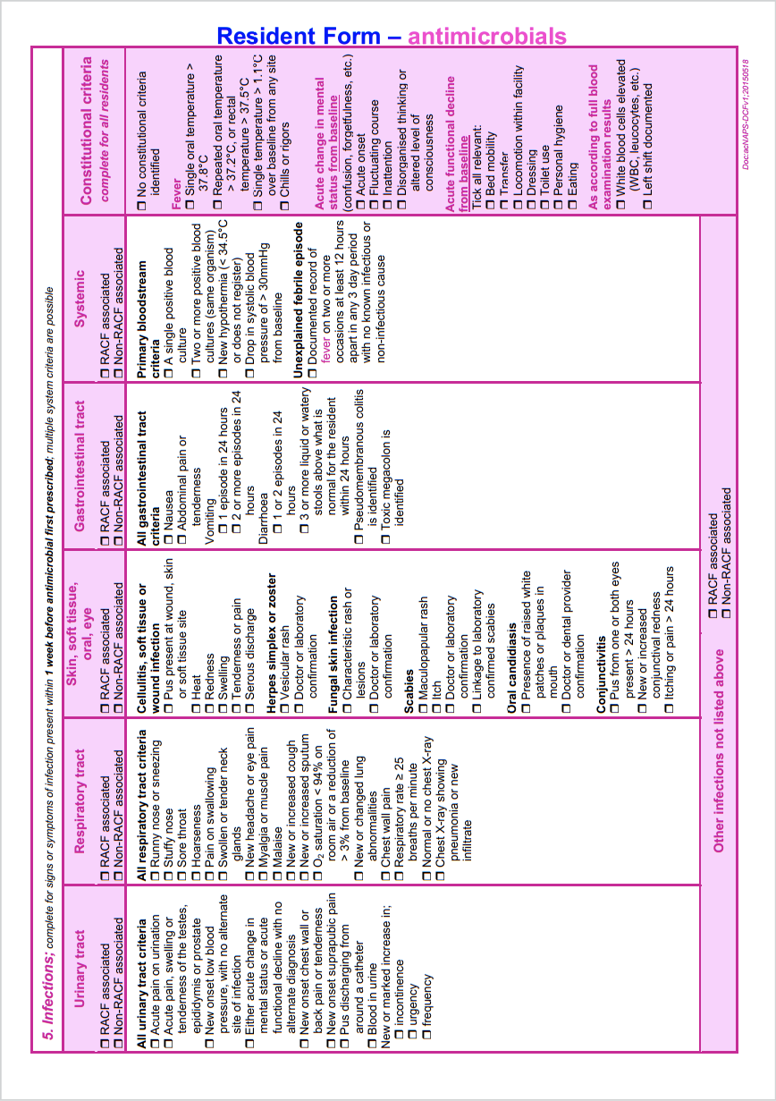

Appendix C - Calculating infection rates in long term care facilities

Australian_guidelines_for_the_prevention_and_control_of_infection_in_healthcare_2024
National Institute for Health and Clinical Excellence (NICE) 2002
Chapter 4 in IFIC Basic Concepts of Infection Control, 3rd edition, 2016 - Surveillance for Healthcare Infections.

