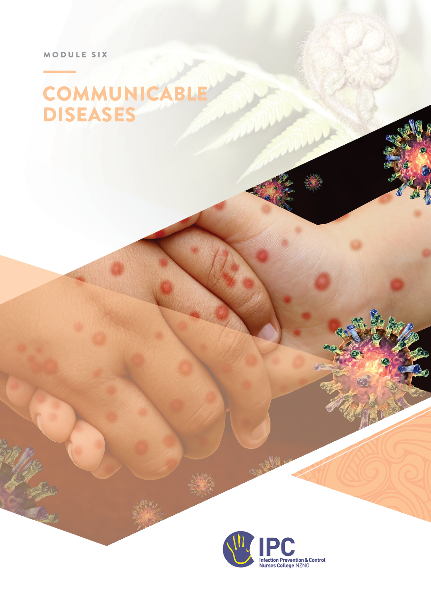
Communicable Diseases
Table of Contents
Objectives 2
Required reading 2
Recommended readings and resources 2
Instructions 2
Overview 3
Key Concepts 3
The Public Health system in New Zealand 3
Notifiable Diseases 4
The role of infection prevention and control 4
Reporting a notifiable disease 5
Contact tracing and follow-up 6
Immunisation 7
Outbreaks of communicable diseases 7
Surveillance for communicable diseases 8
Applying knowledge to practice 10
Scenario 1 10
Scenario 2 11

Objectives
At the completion of this module, you will:
- Have an understanding of the public health system in New Zealand
- Identify communicable diseases which are on the New Zealand notifiable diseases list
- Demonstrate a knowledge of the reporting process for notifiable diseases
- Identify key contacts in public health
- Determine the process for contact tracing for notifiable diseases
- Determine the role of Infection Prevention and Control (IPC) in public health and immunisation
- Demonstrate a knowledge of national surveillance for communicable diseases

Required reading
- Communicable Disease Control Manual – General Considerations section
- Summary of Infectious Disease Management under the Health Act 1956

Recommended readings and resources
- Immunisation Handbook - Health New Zealand I Te Whatu Ora
- The New Zealand Institute for Public Health and Forensic Science (PHF Science) - Website and dashboards.
- The National Public Health Service website and resources
- Guidance on Infectious Disease Management under the Health Act 1956

Instructions
- Read the material.
- Write out your answers to the questions and send the workbook to your mentor.

Overview
A communicable disease is any disease that passes between people or animals. People sometimes refer to communicable diseases as ‘infectious’ or ‘transmissible’ diseases.
Communicable illnesses are caused by viruses or bacteria that people spread to one another through contact with contaminated hands or surfaces, bodily fluids, blood products, food or water, insect bites, or through the air. Some communicable diseases can lead to infection outbreaks in healthcare facilities, aged residential care, schools or early childhood settings.
The Te Whatu Ora | Health New Zealand Communicable Disease Control Manual describes standard practice for public health services to follow for the prevention and control of communicable diseases. Within a healthcare organisation, infection prevention and control (IPC) staff also play a role in the management of communicable diseases.

Key Concepts

The Public Health system in New Zealand
Public Health are responsible for the oversight and management of communicable diseases in Aotearoa New Zealand. The two main government entities responsible are the Public Health Agency and the National Public Health Service.
The Public Health Agency – Te Pou Hauora Tūmatanui was established on 1 July 2022 in an amendment to the Health Act 1956. The Agency is part of the Ministry of Health and leads the Ministry’s work on public health and mental health. Two main areas of work that intersect with IPC are:
- pandemic preparedness (more information here)
- immunisation (more information here)
Which important documents were recently published by the Public Health Agency in relation to these two main areas of work? (Use the links above)
Pandemic preparedness
Immunisation leadership

The National Public Health Service works alongside communities to deliver national, regional and local programmes for achieving healthy outcomes. Each region has a local public health office and Medical Officer of Health. Contact details are available here.
Identify the contact details for your local public health unit (use this link)
Districts covered
Phone number
Email

The New Zealand Institute for Public Health and Forensic Science (PHF Science) is a New Zealand Government-owned research organisation that also has an important role in public health. Their work includes infectious disease intelligence and surveillance as well as supporting pandemic preparedness. PHF Science changed its name from the Institute of Environmental Science and Research (ESR) in July 2025.

Notifiable Diseases
Many, but not all, communicable diseases are notifiable in New Zealand under the Health Act 1956.
A notifiable disease is a disease or injury that health professionals are required to report to the local Medical Officer of Health at the National Public Health Service. This is a legal requirement under the Health Act (1956) and the Hazardous Substances and New Organisms Act (1996).
Notification allows for appropriate public health control measures to be taken to reduce the risk of further spread, for disease surveillance and for monitoring of the effectiveness of control measures. These measures are implemented by medical officers of health, health protection officers and staff at public health units.
The decision to make a disease notifiable is based on the disease’s public health importance, as measured by such criteria as incidence, impact and preventability.
The current List of Diseases Notifiable in New Zealand is available from the ministry of Health website HERE.
Identify five communicable diseases on the Notifiable Disease List
1.
2.
3.
4.
5.

The role of infection prevention and control
In a healthcare setting, IPC may be involved in some aspects of the prevention and control of communicable diseases. IPC staff may be involved in notification of a communicable disease, notification and management of an outbreak, contact tracing, immunisation programmes, follow-up of blood exposures, the implementation of IPC policies, including standard and transmission-based precautions and pandemic management.
An understanding of communicable disease transmission and potential sources is essential in order to implement control measures. With reference to the Communicable Disease Control Manual, list a communicable disease for the sources and modes of infection transmission in the table below
Transmission mode / source | Communicable disease
Insect bite (vector)
Airborne/droplet (respiratory)
Contaminated hands (contact)
Contaminated equipment (indirect contact)
Blood exposure
Food or water

Using your knowledge of standard and transmission-based precautions (TBP), identify the type of precautions required for the care of a resident/patient with the following notifiable communicable diseases.
Communicable disease | Standard and/or TBP and duration of precautions
Campylobacter
Measles
Hepatitis B
COVID-19

Reporting a notifiable disease
In your facility or organisation, which of the departments below would notify public health of a new case of a communicable disease?
Responsibility | Yes / No / n/a
Infectious Diseases doctor or department
Laboratory
Infection prevention and control
GP
Emergency department doctor
Ward doctor

There are four regions in New Zealand for reporting a communicable disease.
Identify the four regions (use this link)
1.
2.
3.
4.

Each region has its own forms and methods for reporting but all include an urgent notification list. Using this link, click on the region where you live and view the urgent notification list.
List three communicable diseases on the urgent notification list that you may encounter in your workplace
1.
2.
3.

Contact tracing and follow-up
Case investigation and contact tracing is a normal part of the management of all notifiable diseases. A new case of a communicable disease in a healthcare setting may require follow up of staff members, other patients/residents and visitors. Public health will oversee all contact tracing and follow-up, but IPC are often asked to identify and follow-up staff and/or residents or patients. Conversations with contacts may be challenging. If you are unsure of how to speak to the patient/resident/other contact, seek advice from your local public health office.

Follow up may require post-exposure prophylaxis, treatment, blood tests or other investigations.
Answer the questions related to contacts
What is contact tracing?
Who is responsible for contact tracing in your facility following laboratory notification of TB in a patient or resident?
Who prescribes any recommended post-exposure prophylaxis (PEP) to staff contacts in your facility?
Does IPC keep any records of communicable disease notifications and/or contact follow-up?

Immunisation
Immunisation has been recognised as one of the most important contributions to the control of communicable diseases over the past several decades. IPC often collaborates with Occupational Health and Public Health on issues involving the immunisation of staff and patients. This requires knowledge of immunisation recommendations. Some workplaces, in the absence of Occupational Health services, engage their IPC healthcare professional to manage Influenza vaccination campaigns collaborating with licensed vaccinators.
The New Zealand Immunisation Handbook is the principal guide in New Zealand and is updated regularly. Immunisation Handbook - Health New Zealand I Te Whatu Ora
Immunisation in your facility
Which immunisations/vaccines are offered to residents/patients?
Which immunisations/vaccines are offered to employees?
Does your organisation keep a record of staff immunisation status for other common vaccine-preventable diseases?
Why is it important for employees to have the annual influenza vaccination?

Outbreaks of communicable diseases
Not all outbreaks of a communicable disease require reporting to public health. However there will be interest in gastro outbreaks where there is a suspected common source e.g. contaminated food or from a person in a high risk category (for example, a food handler, an early childhood service worker) or single cases of chemical, bacterial, or toxic food poisoning such as botulism, toxic shellfish poisoning (any type) and disease caused by verotoxin or Shiga toxin- producing Escherichia coli.
Local public health protocols will dictate if all gastroenteritis outbreaks require reporting. In general, there is an increased threshold for reporting gastro outbreaks in aged-residential care facilities. For example, the Northern Region states:
“You should notify public health if there are 2 or more cases of acute gastroenteritis in your facility in a 48-hour period, or linked to a common source such as a specific meal or event.”
Other regions advise aged-residential care facilities to contact public health if experiencing an outbreak.
Does your facility report outbreaks of gastroenteritis and to whom?

During the COVID-19 pandemic all outbreaks of the disease were notifiable. Although COVID-19 is still a notifiable disease, local outbreaks no longer require reporting to public health.
See also the Outbreak Management module in this course.

Surveillance for communicable diseases
At a national level PHF Science is responsible for the surveillance of communicable diseases. Their surveillance systems provide information about more than 50 priority infectious diseases that require public health action. They are currently responsible for the surveillance of the following:
- notifiable diseases
- outbreaks
- sexually transmitted infections
- influenza viruses
- respiratory, enteric and herpes viruses
Information is reported using dashboards and monthly or annual reports. Access the Digital Library and Dashboards part of the website PHF Science.
Name three PHF Science communicable diseases Dashboards that would be of interest to IPC in a healthcare facility
1.
2
3.

Locally, different types of healthcare settings will have different infection surveillance systems. In a large public hospital, a communicable disease may be reported by the lab or be known on admission. In an aged-residential care facility, routine monitoring of resident health and wellbeing may identify new symptoms consistent with an infection that may be a communicable disease e.g. COVID-19.
How will you find out about any notifiable communicable diseases in your facility?

Applying knowledge to practice
In this section you will have an opportunity to apply the knowledge you have learned in the key concepts section to communicable diseases activities which you may encounter in your job.
Answer the questions for at least one scenario that might be applicable to the facility where you work.

Scenario 1
You are notified of a case of a child with meningococcal meningitis admitted during the night. The boy was seen in the Emergency Department where his condition rapidly deteriorated requiring intubation and resuscitation. The doctor was not wearing appropriate PPE. The boy is now stable in the critical care unit.
Answer the questions relating to this case
Is this a notifiable disease?
Who needs to be notified?
Who is responsible for notification of the case?
What IPC precautions should be implemented and for how long?
Define a close contact of a meningococcal case? (refer Health NZ I Te Whatu Ora guidance on meningococcal disease
Is the doctor who intubated the child considered a close contact?
If the doctor is recommended to have the prophylaxis; who provides the medication?
List 3 different antibiotics that are usually prescribed as prophylaxis for contacts of meningococcal meningitis? (refer Health NZ I Te Whatu Ora guidance on meningococcal disease
What education can IPC provide to ED improve practice in the future?

Scenario 2
You are notified of a cluster of invasive group A streptococcal infections in residents/ patients. All the cases have been receiving wound care. Refer the Communicable Diseases Manual section for invasive group A streptococcal diseases (iGAS).
Answer the questions relating to this case
In which year did iGAS become a notifiable disease?
Who needs to be notified?
Who is responsible for notification of the case in your facility?
List three types of infections that can be caused by iGAS. (refer HERE)
What is the main mode of transmission for iGAS?
What IPC precautions should be implemented and for how long?
What are the three main groups of contacts to consider when contact tracing? (refer HERE)

