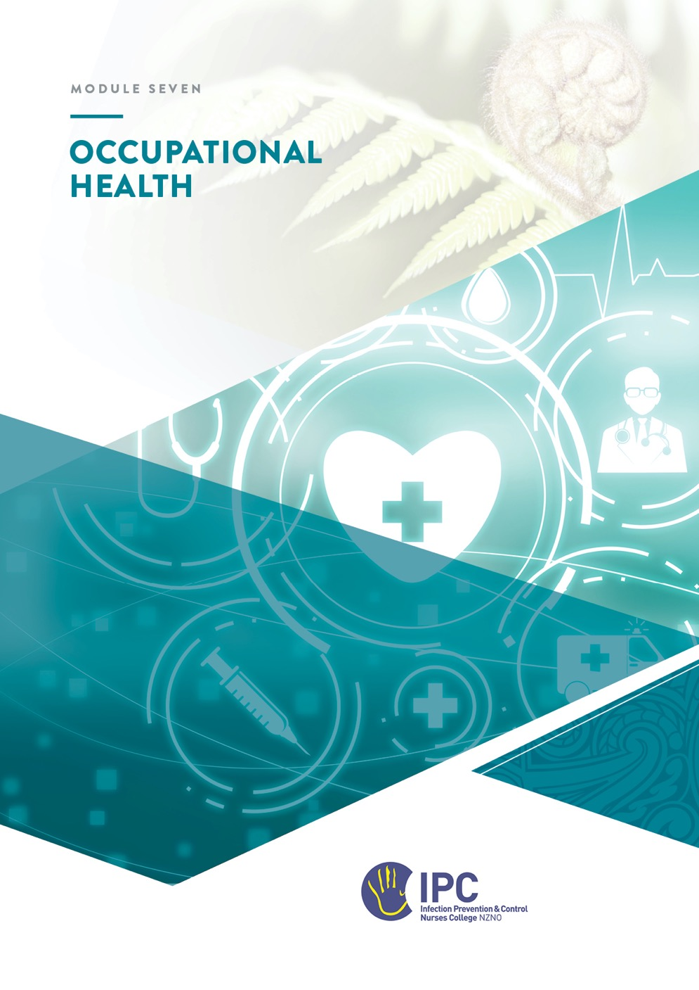

Occupational Health
Table of Contents
Occupational Health 1
Objectives 2
Required reading 2
Recommended resources 2
Instructions 2
Overview 3
Key Concepts 3
IPC Elements of Staff health 3
Responsibilities for Staff Health 3
Pre-employment screening and immunisation 4
Contact tracing 5
Management of occupational exposure to blood and body fluids 5
Respiratory protective programme 6
Annual influenza immunisation programme 8
Work restrictions for communicable diseases 8
Education 8
Documentation and Reporting 9
Applying knowledge to practice 9
Scenario 1 - Tuberculosis 9
Scenario 2 – Blood and body fluid exposure 9
Scenario 3 – Acute respiratory illness (ARI) e.g. influenza/COVID-19/RSV in an aged residential care home or oncology unit 10
Scenario 4 – Diarrhoea and vomiting 11
Scenario 5 - Scabies 11

Objectives
At the completion of this module you will:
- Demonstrate a knowledge of the elements of staff health that relate to the infection prevention and control role
- Describe the screening process for infectious diseases of healthcare workers on employment
- Identify the post-exposure policy for infectious diseases including blood borne pathogens
- Identify the process for staff contact tracing following contact with an infectious disease
- Demonstrate knowledge of the P2/N95 ‘fit-testing’ (respiratory protection programme) in your organisation (if this is applicable)
- Determine the level of IPC involvement in the annual influenza immunisation programme
- Demonstrate knowledge of employee work restrictions in the workplace for communicable diseases.

Required reading
- NHMRC Australian Guidelines for the Prevention and Control of Infection in Healthcare – Section 4.2 Staff Health and Safety
- Guidance on Infectious Disease Management under the Health Act 1956
- Health and Safety at Work Act 2015 - overview on website: https://www.worksafe.govt.nz/laws-and-regulations/acts/hswa/

Recommended resources
- Communicable Disease Control Manual
- New Zealand Immunisation Handbook 2020
- CDC Immunisation of Healthcare Personnel
- CDC Infection Control in Healthcare Personnel
- Queensland Health. Management of occupational exposure to blood and body fluids – Infection prevention and control. v5.4 October 2025. Available HERE.

Instructions
- Read the material.
- Write out your answers to the questions and send the workbook to your mentor

Overview
Occupational Health is a distinct professional role to that of infection prevention and control (IPC). However, the health and safety of staff in the healthcare setting incorporates IPC principles to provide a safe environment for healthcare workers and patients. This includes the prevention and management of occupational infectious risks, exposures, and illnesses. The organisation’s Occupational Health (Occ Health) programme (or some aspects of it) may link into the IPC programme or in some organisations, staff health issues related to infections may be incorporated into the IPC programme.

Key Concepts
The elements of staff health related to IPC may include pre-employment screening, , immunisation, IPC education, work restrictions for infectious diseases, prevention and follow up of a blood or body fluid exposure, and management of skin issues related to hand hygiene products. To address these elements a knowledge of certain key concepts is required and include incubation periods and associated work restrictions for infectious diseases, the interpretation of serology results for post-exposure follow up, contact tracing methods, the cold chain for vaccines, and the correct choice and use of PPE.

IPC Elements of Staff health

Responsibilities for Staff Health
Review your organisation’s policies and answer the questions | Yes / No
Is there a person or department responsible for Occ Health in your facility that is separate from IPC?
If there is no Occ Health dept/programme in the facility, who provides Occ Health advice to staff?
Is there access to an Occ Health Physician?

Who is responsible for these elements of staff health? | IPC/Occ Health/staff member GP/Other/NA
Review of pre-employment screening results
Provision of required employment vaccines
Annual vaccination programme e.g. influenza
Follow-up of blood/body fluid exposures
Staff contact tracing following exposure to communicable disease e.g. meningococcal meningitis, TB, scabies
Respiratory protection programme e.g. N95/P2 fit testing
Advising work restrictions for infectious illness
MRSA colonisation or infection in staff member
PPE and safe handling of sharps education
Advice and/or management of hand dermatitis associated with hand hygiene products

Pre-employment screening and immunisation
Source the pre-employment and employee immunisation policies for your organisation.
Indicate if the following communicable diseases are included in pre-employment screening and if immunisation is a requirement of employment for clinical staff?
Disease | Included? | Immunisation requirement?
Chickenpox
Measles
Rubella
Mumps
Tuberculosis (TB)
Pertussis
Hepatitis B
Hepatitis A
COVID-19

Some clinical staff may require immunity to certain infectious diseases due to their role and/or patients they work with.
List any specific groups of staff who are required to demonstrate immunity for the following diseases e.g. surgeons; midwives; staff in oncology, NICU, paediatrics or respiratory wards
Hepatitis B
Pertussis
Influenza
Measles
Chickenpox

The work restrictions and PPE required to care for someone with an airborne infectious disease e.g. Measles and Chickenpox, often depends on the staff member’s immunisation status to the organism. Complete the following table using your local policy.
Organism | Immunisation status | Precautions / restrictions
Varicella | Immune
Varicella | Non-immune
Measles | Immune
Measles | Non-immune

MRSA screening
Pre-employment screening for MRSA in clinical staff is no longer recommended unless they have risk factors for colonisation e.g. chronic dermatitis of hands, previous MRSA infection.

What are the indications for pre-employment MRSA screening in your facility?

Contact tracing
Contact investigations for notifiable communicable diseases e.g. meningococcal meningitis, Measles, TB, are overseen by the medical officer of health of the region in which the index case is notified. If a case was identified in a healthcare facility, Public Health will often engage IPC or Occ Health assist in identifying any staff contacts.
What does contact tracing mean?
Who is considered a staff contact in a case of Neisseria meningitidis invasive disease in NZ (refer HNZ Communicable Diseases Manual – Meningococcal invasive disease)

Management of occupational exposure to blood and body fluids
An occupational exposure is an incident that exposes a healthcare worker to another person’s blood or body fluid during their work, which may place them at risk of blood borne virus infection. This can include:
- A percutaneous injury, where the health care worker’s skin has been cut or penetrated by a needle or other sharp object that may be contaminated with blood or other body fluid. For example, a needlestick injury or cut with a sharp object such as a scalpel blade.
- A mucosal exposure, where there is contact of mucous membranes or non- intact skin (e.g. exposed skin that is chapped or abraded) with blood or body fluids. For example, a blood splash to the eyes.

Blood Borne Virus (BBV)
Occupational exposures to blood and body fluids in healthcare settings have the potential to transmit hepatitis B virus (HBV), hepatitis C virus (HCV), and/or human immunodeficiency virus (HIV).

In addition to blood and body fluids containing visible blood, the following fluids are considered potentially infectious:
- Semen
- vaginal secretions
- cerebrospinal fluid
- synovial fluid
- pleural fluid
- peritoneal fluid
- pericardial fluid
- amniotic fluid
Although semen and vaginal secretions have been implicated in sexual transmission of HBV, HCV and HIV, they have not been implicated in occupational transmission from patients to healthcare workers.

The following resource may help you to complete the following table:
Queensland Health guidelines Management of occupational exposure to blood and body fluids - Infection prevention and control - October 2025)

Define or describe the following
What immediate care should be taken for the exposed person following a needlestick exposure
Who is the ‘Source’
What is post exposure prophylaxis (PEP) for BBV’s
Does your organisation have a policy for post exposure prophylaxis for Blood or body fluid exposures?
Who does the follow-up for this exposure in your facility?

Respiratory protective programme
(Reference: NSW CEC Respiratory Protection in Healthcare Version 1)

The use of respiratory protection should be considered as an essential element of defence in the hierarchy of infection prevention measures; refer to Figure 1. Respiratory and facial protection is required for those organisms that are usually transmitted via the droplet or airborne route, or when airborne particles have been artificially created, such as during an AGPs.
A respiratory protective programme includes vaccination, and staff education and training for:
- use of eye protection
- use of surgical masks and respirators
- respirator fit-testing and fit-checking
- identification and management of aerosol-generating procedures

Find the policies and procedures in your organisation relating to the elements of a respiratory protection programme and answer the following questions.
Which elements of a respiratory protection programme are included in your facility?
Who is required to be ‘fit-tested’ for a respirator in the facility?
What are the two methods of fit-testing commonly used?
Who provides fit-testing in the facility (if undertaken)
What does fit-checking mean?

Annual influenza immunisation programme
Determine the components of an annual influenza programme
What is an influenza immunisation programme?
Why is it important to have this programme in your facility?
Why is it important for IPC to be involved?
When does planning for the annual staff influenza programme start?
 | Action of IPC | Action of Occ Health (internal or external provider)
If there is an influenza immunisation programme, describe the involvement of IPC & Occ Health as it relates to healthcare workers

Work restrictions for communicable diseases
Define ‘work restrictions’

What are the work restrictions for staff in your organisation who report the following conditions?
Diarrhea and/or vomiting
Influenza
COVID-19
Herpes simplex (cold sores)
Conjunctivitis (pink eye)
Chickenpox

Education
Determine if there are educational sessions for healthcare workers for the following topics:
Education topics | Who provides the education?
- Personal Protective Equipment
- Standard and Transmission-based Precautions and Risk Assessment
- Sharps safety programme

Documentation and Reporting
- Determine if any records are kept for staff members who are followed up for a blood or body fluid exposure or exposure to a communicable disease.
- Who is responsible for maintaining these records – Occ Health, IPC, GP, other?

Applying knowledge to practice
Review the following scenarios and answer the questions for scenarios that may occur in your facility. Indicate if the actions are the responsibility of Occ Health or IPC in the facility/organisation.

Scenario 1 - Tuberculosis
A new case of tuberculosis (TB) was just diagnosed in an inpatient. This patient has been in a four-bedded room for five days. IPC precautions are immediately implemented.(Refer Page 121-122 of ‘The Guidelines for Tuberculosis Control in New Zealand 2019’)
Questions | Answers & responsibility
Who overseas contact tracing?
What pre-employment screening results will be important at this time?
What aspect of the respiratory protection programme is important for this incident?

Scenario 2 – Blood and body fluid exposure
A cleaner is stripping a bed and is pricked with a needle. Assess the situation and your organisation’s policies to see what needs to be carried out. (Also refer to Awanui Labs BBFE information)
Questions | Answers & responsibility
Does your organisation have a policy for post exposure prophylaxis for needle stick injuries?
Who does the cleaner report the incident to?
Who is responsible for following up this incident?
Where does the cleaner go to have their blood samples taken?
Who follows up with the results?
What should healthcare workers who come in contact with body fluids be vaccinated against?
What education might you provide to prevent this incident occurring again?
Where can the employee access the post-exposure drugs for HIV?

Scenario 3 – Acute respiratory illness (ARI) e.g. influenza/COVID-19/RSV in an aged residential care home or oncology unit
A carer at work has onset of a fever, chills, sore throat, and body aches. There is an increase of ARI in the local community. The carer has not been vaccinated for influenza or COVID-19.
Questions | Answers
What should the carer do?
Who should they notify?
Is there any contact tracing required?
How would you determine the influenza and COVID immunisation status of other healthcare workers and patients/residents?
What are the work restrictions relating to ARI? (you may provide a reference for any current Te Whātu Ora guidelines)

Scenario 4 – Diarrhoea and vomiting
While working, a healthcare worker experiences severe abdominal cramping and has three episodes of explosive diarrhea and one episode of vomiting.
Questions | Answers
What should the carer do?
Who should they notify?
What gastrointestinal diseases would you suspect?
When is it necessary to send a stool sample from the HCW?
What are the work restrictions required for gastrointestinal illness?

Scenario 5 - Scabies
A patient/resident has just been confirmed with a scabies infestation
Questions | Answers
Which staff would be considered as having significant exposure to the scabies?
How would you work out who these staff contacts are in your facility for this scenario? (e.g. rosters / clinical notes etc.)
Why is a long-sleeved isolation gown required as part of PPE when caring for a scabies patient?
What would the follow-up of conformed staff contacts involve for scabies exposure?

