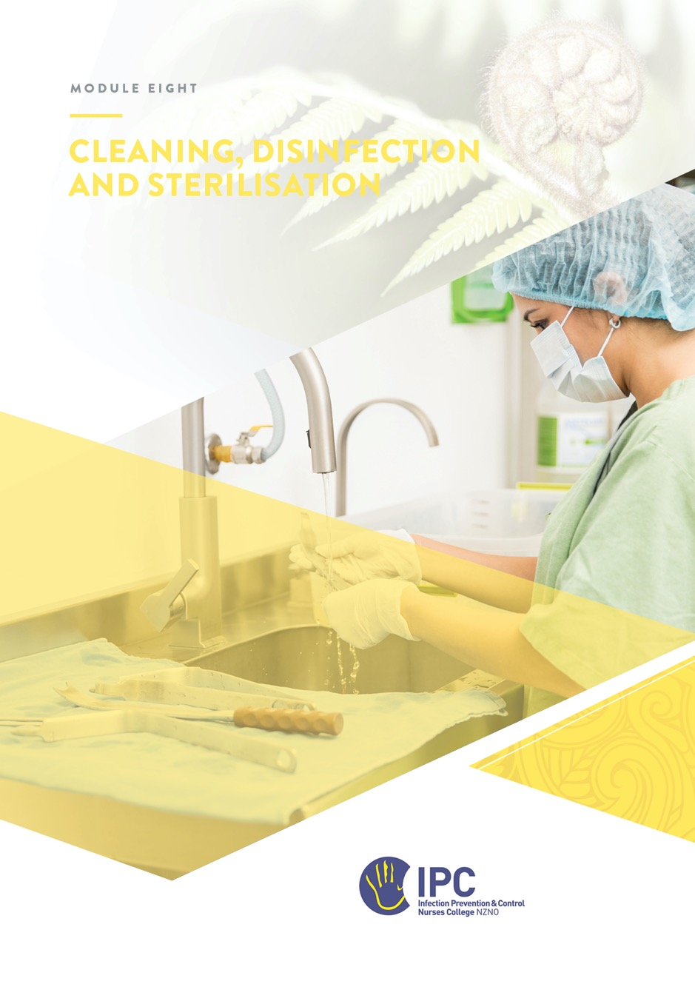

Cleaning, Disinfection, and Sterilisation of Medical Equipment and Devices
Table of Contents
Cleaning, Disinfection, and Sterilisation of Medical Equipment and Devices 1
Objectives 2
Required Readings 2
Additional readings and reference material 2
Instructions 2
Overview 4
Governance 4
Key Concepts 5
Spaulding classification 5
Cleaning 5
Disinfection 6
Endoscopy Reprocessing 8
Sterilisation 8
Manufacturer’s recommendations 10
Single-use items 10
Other reprocessing considerations 10
Applying Knowledge to Practice 11
Cleaning process 11
Disinfection process 11
Sterilisation process 12
Transportation and handling of contaminated medical equipment/devices 13
Storage of reprocessed medical devices and equipment 13
Single use items 14
Documentation and Reporting 14
Tour of Key Reprocessing Areas 14
Sterile Services Tour 15
Endoscopy Unit Tour 15
Other areas 17

Objectives
At the completion of this module, you will:
- Demonstrate a basic knowledge of cleaning, disinfection, and sterilisation of medical equipment/devices by completing the exercises in this module.
- Be familiar with the requirements from relevant standards and guidelines for reprocessing medical devices within Sterile Services, Endoscopy and other relevant departments.
- Describe the Spaulding Classifications System and give examples of each category.

Required Readings
- Australian Guidelines for the Prevention and Control of Infection in Healthcare (updated October 2024). Section 3.1.4 Reprocessing of medical devices. Pages 76-83. (LINK)
- Centres for Disease Control and Prevention (CDC) - Chemical Disinfectants (LINK)

Additional readings and reference material
- AS 5369:2023, Reprocessing of reusable medical devices and other devices in health and non-health related facilities. (note that this standard is not freely available but may be purchased from the Standards Australia Store and distribution partners.
- GENCA/GESA Infection Prevention and Control in Endoscopy 2025 Update (LINK)
- The Royal New Zealand College of General Practitioners (RNZCGP) Foundation Standard guidance for reprocessing reusable medical devices (RMDs) as per AS 5369:2023 (LINK)
- Australasian Society for Ultrasound in Medicine (ASUM). Guidelines for Reprocessing Ultrasound Transducers (LINK)
- The Royal Australian College of GPs (RACGP) Infection Control Guidelines (updated 2024) Chapter 10, Reprocessing reusable medical devices (LINK)
- Rowan et al (2023). ‘A review of Spaulding's classification system for effective cleaning, disinfection and sterilization of reusable medical devices: Viewed through a modern-day lens that will inform and enable future sustainability’. https://doi.org/10.1016/j.scitotenv.2023.162976

Note: In this module ‘cleaning’ refers to the cleaning of medical devices and equipment. Environmental cleaning is covered in Module 2 Part 1, Standard Precautions. This module does not cover antiseptics or disinfectants used on the skin.

Instructions
- Read the material.
- Complete the answers to the questions and send the workbook to your mentor.
- Discuss any questions as required with your mentor.
- Depending on the type of facility you are working in, ask your manager to arrange visits to departments that reprocess medical devices.

Overview
One of the roles of IPC is to provide advice on the cleaning, disinfection, and sterilisation of reusable patient care equipment. The NZS8134:2021 Part 5.2.9 requires facilities to ensure that reusable medical devices and equipment are decontaminated and reprocessed in line with best practice.
This module is designed to help you become familiar with the processes involved in the reprocessing of medical devices/equipment. The goals of safe reprocessing of medical devices/equipment include:
- Preventing transmission of microorganisms to personnel and consumers/ patients/ residents
- Minimising damage to medical devices/equipment from foreign material (e.g., blood, body fluids, saline and medications) or inappropriate handling.
What is the overarching standard for reprocessing medical devices and equipment that facilities in New Zealand should comply with?

The standard applies to all facilities and departments that clean, disinfect or sterilise medical devices and equipment including sterile services, endoscopy services, day surgery, and all office-based practices that use small (bench-top) sterilisers.

In this module you will be asked to become familiar with key concepts for reprocessing. If possible, after you are familiar with these concepts, arrange a tour of the departments that provide reprocessing services. Use the check lists provided under the tour section to help guide you and to document your experiences.

Governance
Governance is a crucial aspect of reprocessing, ensuring safe, effective, and ethical patient care. It encompasses a range of elements, including leadership, accountability, and quality assurance, all working together to create a high-quality reprocessing service. Effective governance in reprocessing involves establishing standards with clear policies and procedures, developing the workforce, fostering collaboration and a culture of safety, and promoting continuous improvement.
Collaboration includes a multi-faceted approach with input from professional bodies (NZNO, NCNZ), national programmes (NEQIP) and individual units.
In your facility describe any working or management relationships you share with endoscopy and/or sterilisation services?

Key Concepts
An important place to start is with Spaulding’s Classification System. This system was first used in the 1950s and remains applicable, however, changes have occurred in the last 60 years which means that Spaulding Classification needs to be used in combination with a quantitative risk-based classification system to help address modern-day technical and patient risk challenges.
Spaulding believed that the nature of decontamination could be understood more readily if instruments and items for patient care were divided into three categories based on the degree of risk of infection transmission involved in the use of the items.
In the section below define each of the device classifications. Identify the method of reprocessing used for each of the classifications and then give an example of medical devices that fall into each of the categories based on the definition of each device classification. Where possible use example of equipment from your facility/organisation. Refer to this resource from the RNZCGP The Spaulding Classification System for decontamination.

Spaulding classification
Device classification | Definition | Method/level of reprocessing | Device Examples
Critical
Semi-critical
Non-critical

Cleaning
Cleaning is an essential part of reprocessing to ensure the medical device is safe. For non-critical equipment and patient devices, cleaning alone may be sufficient to render the device safe for the next patient. For semi-critical and critical medical devices, cleaning must always occur prior to disinfection or sterilisation processes. If an item cannot be cleaned, it cannot be further processed or reused.
There are many products available in healthcare for cleaning equipment. Some cleaning wipes contain both a cleaning agent and a disinfectant agent - a two-in-one product. Ensure you follow manufacturer ‘Instructions for Use’ (IFU) for compatibility and effectiveness when selecting a cleaning product for equipment.

Define key terms about cleaning and then give examples of processes or products. (Refer required reading, Australian Guidelines for the Prevention and Control of Infection in Healthcare).
Term | Definition | Examples
Cleaning
Detergents
Enzymatic cleaner/detergent
Ultrasonic cleaning |  | Not applicable

Disinfection
Disinfection is a process that inactivates non-sporing infectious agents. Disinfection processes may use heat, chemical or light-based methods.
There are three levels of disinfection depending on the intended use of the device or equipment, high, intermediate and low level disinfection.

Thermal disinfection
Thermal disinfection uses moist heat at different temperatures and cycle times to disinfect devices. In a sterile services department a washer disinfector machine is used for this process.
The table below gives some examples of thermal disinfection use.
Levels of thermal disinfection
Level of disinfection | Spaulding classification and examples
High level | Interim disinfection of critical devices prior to sterilisation. Semi-critical devices that cannot tolerate sterilisation e.g. certain laryngoscopes.
Intermediate level | Semi-critical devices that may or may not undergo further sterilisation e.g. vaginal speculae, laryngoscope blades.
Low-level | Non-critical equipment that can withstand exposure to thermal disinfection e.g. bedpans, carts, walking frames.

Chemical disinfection
Chemical disinfection is widely used to reprocess non-critical patient equipment and some semi-critical devices that are unable to withstand thermal sterilisation e.g. endoscopes, intracavity probes. Disinfection processes may be manual or automated.
There are many chemical disinfectants in use in the healthcare setting for surfaces or equipment. A chemical disinfectant used to reprocess medical devices must be labelled as “instrument-grade disinfectant. A “hospital-grade disinfectant” must not be used to reprocess a reusable medical or other device as is suitable for cleaning environmental surfaces in a healthcare setting and is generally not the appropriate product to reprocess reusable medical devices.
Chemical disinfectants are marketed in different formats such as impregnated wipes, solutions or aerosols. When choosing a disinfectant, its properties are important to consider.
Refer to the information from the CDC HERE and list four properties of an ideal disinfectant that you think are important.
Ideal disinfectant properties
1.
2.
3.
4.

The following disinfectants are commonly used, so it is important to have an understanding of their advantages and disadvantages.
Refer to the required reading CDC Chemical Disinfectants and complete the table below.
Disinfectant | Advantages  (provide 2 examples) | Disadvantages  (provide 2 examples)
Alcohol
Hypochlorites (Chlorine Bleach)
Ortho-phthalaldehyde (OPA)
Quaternary ammonium compounds
Phenolics
Hydrogen peroxide
Chlorine dioxide

As per Spaulding classification, high-level disinfection must be used for endoscopes, intracavity probes and other patient equipment that comes into contact with mucous membranes and is unable to undergo sterilisation processes e.g. respiratory testing equipment, ocular lenses.

Light disinfection
Ultraviolet (UV)-C light for disinfection has become more popular since the COVID-19 pandemic and is primarily used to disinfect water, air and environmental surfaces. However, UV-C disinfection systems for semi-critical medical equipment, such as ultrasound probes and endoscopes are now also available. It should be noted that a review of UV disinfection in 2022 found no evidence that high-level disinfection of semi-critical devices was actually achieved, despite manufacturer claims. However, this technology is evolving rapidly.
With reference to this research article: Shedding a light on ultraviolet-C technologies in the hospital environment. Demeersseman, N. et al. Journal of Hospital Infection, Volume 132, 85 – 92 (LINK), describe one disadvantage of using UV-C technology to disinfect equipment.

Endoscopy Reprocessing
Infections related to inadequate reprocessing of endoscopes are well documented. Recent endoscopy-associated outbreaks of carbapenemase-producing Enterobacterales (CPE) has emphasised the need for stringent infection prevention and control practices when reprocessing endoscopes. Endoscopes cannot tolerate thermal disinfection, therefore the most common method used to reprocess endoscopes is high-level disinfection using an automated endoscope reprocessor.
For a comprehensive guide to reprocessing endoscopes refer to GENCA/GESA Infection Prevention and Control in Endoscopy 2025 Update (LINK).

Sterilisation
Sterilisation destroys all microorganisms on the surface of an object or in a fluid to prevent disease transmission associated with the use of that item.
There are a number of methods to achieve sterilisation. Sterilisation using steam under pressure (autoclave) is the most common method and is usually the only method found in office-based practices. Small (benchtop) sterilisers / autoclaves are classified according to the type of cycle they run – Classes S, B or N. A detailed description of the different classes and their application is found in The RACGP Infection Control Guidelines Section ‘Sterilisers’ (LINK). In large sterile service departments larger sterilisers are used.
Other sterilisation systems include those that use dry heat, ionising radiation, ethylene-oxide, peracetic acid or hydrogen peroxide plasma sterilisation. These low-temperature sterilising systems are only used in sterile service departments in larger hospital facilities.
One of the methods to ensure sterility assurance is monitoring of the steriliser function. Using the following CDC IPC resource Best Practices for Sterilization Monitoring, define the following tests and monitoring systems.
Indicator / test | Define (what are they testing?)
Mechanical / physical monitoring
Chemical indicators
Biological indicators
Bowie Dick Test

To effectively sterilise a device or surgical instrument, multiple processes are involved as illustrated in the diagram below.
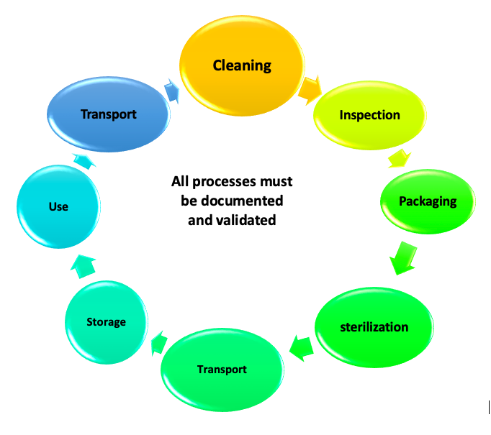
Practitioners who use a steriliser at work should have the appropriate training and knowledge. It is outside the scope of this module to cover all the knowledge required for sterilisation practice.

Manufacturer’s recommendations
It is important that when reprocessing equipment to follow the manufacturer instructions for use (IFU) to prevent damaging the equipment. Manufacturer IFU for all medical devices/equipment must be easily accessible to staff carrying out the reprocessing.
The Joint Commission (an accreditation body in the USA) has described their expectations for the content of IFU for medical devices and instruments (LINK).

What information do you think the manufacturer should provide in the IFU with each medical device?

Single-use items
Single-use devices must not be reprocessed for reuse.
A manufacturer may classify its product as single use for several reasons:
- difficulty in effectively cleaning the item e.g. narrow lumens
- the materials used to manufacture the item may not withstand disinfection or sterilisation procedures and may pose a safety risk for the subsequent patients to use the item.
- There may be significant work health and safety risk in handling the item in the reprocessing department e.g. scalpel blades, needles and other sharps.

Other reprocessing considerations
With any system or process for reprocessing medical devices and equipment, facilities must also follow best practice guidelines and industry standards for the following:
- Reprocessing facility design
- Transportation of medical devices (if not point-of-use)
- Storage of equipment
- Quality assurance monitoring and validation testing
- Instrument tracking and recall
- Documentation
- Staff health and safety
- Staff education
- Equipment maintenance

Applying Knowledge to Practice
To complete this section of the workbook, you may need to gather information from different departments in your facility.

Cleaning process
Cleaning – Process
Why is cleaning the first step of reprocessing of medical devices?
What cleaning processes are used for the cleaning of medical devices in your facility? (manual, washer/disinfector, ultrasonic)
Which cleaning products are used in your facility (include if a combined cleaning and disinfection product)

Disinfection process
Which of the disinfection processes (thermal, chemical or UV-C light) are used in your facility?
Disinfection process | Example of equipment or medical device
Thermal disinfection
Chemical disinfection
UV-C disinfection

If you use a disinfectant wipe or a combined detergent/disinfectant wipe, identify the active disinfecting compound(s) e.g. a phenolic, alcohol and list it below:
Disinfectant compound in wipes ________________________________________________

Cleaning and/or disinfection of common non-critical and semi-critical items
Consider the cleaning and/or disinfection of the following common non-critical and semi-critical items patient equipment used in healthcare and complete the table.
Which product or process is used? Who is responsible for reprocessing the item? How often does this occur?
Item | Non-critical or semi-critical? | Product/process used in your facility | Responsibility
BP cuff
External ultrasound scanner head
Vaginal, rectal, ENT, TOE or other endocavity probes
Patient sling
Bed pan
Stethoscope
Glucometer platform
Electronic thermometers
IV poles, wheelchairs, beds, call bells
Gastroscope or colonoscope
Reusable resuscitation Ambu Bag and mask
Tonometer lens

Sterilisation process
For each of the sterilisation processes listed below that are used in your facility, list the equipment that it is used for.
Sterilisation Methods | Equipment
Steam sterilisation | (list 3 items)
Hydrogen peroxide gas plasma (Sterrad™)
Vapour hydrogen peroxide (Steris™)
Chlorine dioxide gas steriliser

Transportation and handling of contaminated medical equipment/devices
Complete the answers for your facility
How is contaminated equipment transported to:
- Reprocessing department or area?
- Within facilities (department to department)?
- Between facilities (vehicle transport)?
Does the way devices are transported meet best practice standards?
Are there policies and procedures that include information on transportation of contaminated equipment or medical devices?

Storage of reprocessed medical devices and equipment
Complete the answers
Where are sterile items stored?
Are items stored in a way that meets the best practice standards?
Are there policies/procedures regarding the storage of sterile equipment.

Single use items
Complete the answers
List the reasons why single use devices are often re-used
What is the universal symbol that denotes single use?
Are any single use items reprocessed in your facility and if so what process is used?

Documentation and Reporting
Does your facility have a policy for reprocessing reusable medical devices?
Does your facility have a policy on the management of single use devices?
Who is responsible for investigating a sterilisation failure resulting in a look-back of patients?

Tour of Key Reprocessing Areas
There are specific departments within larger facilities which perform the majority of the cleaning, disinfection and sterilisation of medical devices. These departments include Sterile Supplies, and the Endoscopy Reprocessing Department. It is important that you become familiar with these areas. If possible, ask your manager to contact the manager of these departments and arrange a visit.
Before you go on a tour of a reprocessing department in your facility (or elsewhere), ensure you are familiar with concepts that underpin the reprocessing of non-critical, semi-critical, and critical equipment and instruments. Revisit the required reading: Australian Guidelines for the Prevention and Control of Infection in Healthcare (updated October 2024). Section 3.1.4 Reprocessing of medical devices. Pages 76-83. (LINK) and the latest GENCA/GESA Infection Prevention and Control in Endoscopy Guidelines (LINK)

NB: It is not a requirement of this module to complete these tours if you do not work in a facility that uses these services.

Below are things you need to look for and ask about on your tours.

Sterile Services Tour
Notes on Your Experience
- Workflow - contaminated to clean and then sterile
- Follow an item/tray from decontamination and cleaning to sterilisation
Ask to see the following:
- Bowie Dick Test
- Biological indicators
- Chemical indicators
- Physical indicators
- Documentation and recording of indicators
- What is the process when there is a positive indicator?
Review the use of:
- ultrasonic cleaner
- washer/ disinfector
Packing area
Does the department have policies and procedures?
Where do they keep manufacturers recommendations?
Does the area have dedicated hand hygiene sinks?
Use of PPE – gloves, gown, face protection

Endoscopy Unit Tour
An endoscopy reprocessing tour should review additional key elements to ensure patient safety; including but not limited to, pre-cleaning, manual cleaning, drying, storage and microbiological monitoring. Emphasis should be placed on adherence to guidelines, proper training, and documentation at each stage.

Endoscopy Unit Tour | Notes on Your Experience
Follow one endoscope from the patient through reprocessing to storage (see also audit example below)
Which type of automated endoscope reprocessor (AER) is used?
What chemical high-level disinfectant is used in the AER?
Are there comprehensive policy and procedure documents readily available?
Do staff use the most recent GENCA/GESA Infection Prevention and Control guidelines (2025 update)?
Do staff have easy access to manufacturer’s recommendations for the AER?
Do staff undertake a peer review annually of their reprocessing practice?
Are any other high-level disinfection processes for endocavity probes

Endoscopy reprocessing audit example
Endoscopy Reprocessing | Yes | No | Comments’/Action
Pre-Cleaning
Precleans the flexible endoscope at point of use.
Manual Cleaning
Is manual cleaning performed?
If yes, are there procedures in place?
Is leak testing performed? When?
Drying
How is the drying system carried out?
Is the drying within policy and manufacturer’s range?
Is there a system for tracking the drying verification?
Storage
How are the scopes stored?
Is there a system for tracking the storage duration?
Microbiological monitoring
What microbiological monitoring is undertaken?
Quality improvement
Is there a focus on evaluating procedures, controls, testing and staff training?

Other areas
Visit any other departments in your facility e.g. urology, gynaecology, cardiac investigations, respiratory investigations, that reprocesses semi-critical items requiring high-level disinfection and complete the table with the information.
Department | Devices/equipment reprocessed | Method of reprocessing

